**FINAL PROJECT REPORT**

**DATA ANALYSIS OF A DRUG REVIEW DATASET**

**LAKSHMI INDIRA KUPPA**

**PROF. SANJA AVRAMOVIC**

**HAP780- DATA MINING**

ABSTRACT

Objective - The objective of this study is to analyze patient reviews on specific drugs and related medical conditions to predict patient satisfaction and identify potential side effects. We aim to leverage both sentiment analysis and classification techniques to gain insights into patient experiences, thereby informing better healthcare decisions.

Data - The dataset used in this study is a drug review dataset obtained from online pharmaceutical review sites. It includes patient reviews, drug names, conditions treated, ratings, and other relevant information. The dataset comprises 1,500 rows of data, focusing on patient demographics, drug usage, and review content. The independent variables include the drug name, condition, review content, rating, useful count, word count, and sentiment. The dependent variables are patient satisfaction (binary classification) and the sentiment of the review.

Method - We use Weka 3.8 for data preprocessing, classification, clustering, and attribute selection. The data is preprocessed to handle missing values, standardize text, and generate additional features such as word count and sentiment. We also apply clustering algorithms like K-Means to identify natural groupings in the data. Classification algorithms including J48, Random Forest, Naive Bayes, and SMO are used to build predictive models. The models are evaluated using metrics such as accuracy, precision, recall, and F1-score. We also use ROC area to compare the models' performance.

Result - The results indicate that J48 has the highest accuracy, closely followed by SMO. The analysis revealed that the J48 Decision Tree model, even without clustering, was the most effective in predicting patient satisfaction ratings based on the available variables.

Keywords - patient satisfaction, drug reviews, classification algorithms, clustering, Weka, predictive modeling

**When you need to know if a medication really works, why not Ask a Patient?**



Medication review, as an overarching term, has been considered to be an important intervention for many years.

[**Room for review – a guide to medication review: the agenda for patients, practitioners and managers**](http://www.webarchive.org.uk/wayback/archive/20140627111246/http%3A/www.npc.nhs.uk/review_medicines/intro/resources/room_for_review.pdf) was published by the Taskforce on Medicines Partnership, The National Collaborative Medicines Management Services programme in 2002. This document suggested key principles for the process of medication review:

* All patients should have a chance to raise questions and highlight problems about their medicines.
* Medication review seeks to improve or optimise the impact of treatment for an individual patient.
* The review is undertaken in a systematic way, by a competent person.
* Any changes resulting from the review are agreed with the patient.
* The review is documented in the patient's notes.
* The impact of any change is monitored

**DATASET DESCRIPTION**

1. **drugName (categorical):** This field contains the name of the drug being reviewed by the patient.
2. **condition (categorical):** This field indicates the medical condition for which the drug was prescribed.
3. **review (text):** A textual review provided by the patient, detailing their experience with the drug.
4. **rating (numerical):** A 10-star rating given by the patient, reflecting their overall satisfaction with the drug.
5. **date (date):** The date on which the review was entered into the system.
6. **usefulCount (numerical):** The number of users who found the review helpful.

**METHODOLOGY**

The data preprocessing stage involves cleaning the dataset by addressing missing values, duplicates, and irrelevant data, and converting categorical variables like drug names and conditions into numerical representations for analysis. Key features are extracted from the review text, including sentiment, common terms, and themes. Sentiment analysis is then performed on the review text to classify reviews as positive, negative, or neutral. Finally, a predictive model is developed using machine learning techniques to forecast patient satisfaction based on drug name, condition, and review content, with continuous evaluation and refinement of the model's accuracy.

**DATA PREPROCESSING**

Data preprocessing is a crucial step in the data analysis pipeline. It involves cleaning, transforming, and organizing the raw data into a format suitable for analysis. In this project, the preprocessing of the drugs_dataset was conducted using SQL. The following steps outline the process, with explanations for each operation performed.

1. Data is imported into SQL Server Management Studio (SSMS)

The first step in working with the dataset is to import it into SQL Server Management Studio (SSMS). This step ensures that the data is available within the SQL environment, allowing for further preprocessing, querying, and analysis.

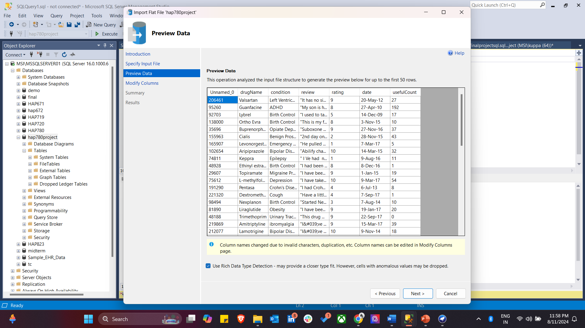

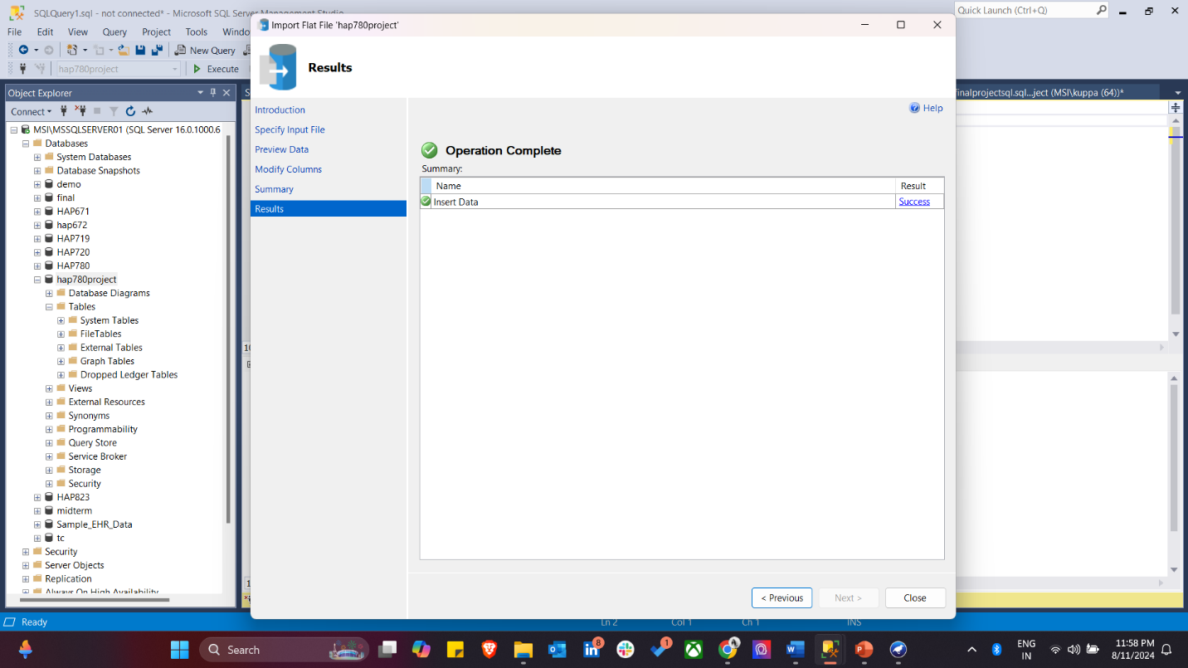

1. Initial Data Collection and Review

This step in data preprocessing is to review the entire dataset to understand its structure, followed by standardizing the data types of each column to ensure consistency.

*-- Select the entire dataset for review*

*USE hap780project;*

*SELECT * FROM dbo.drugs_dataset*

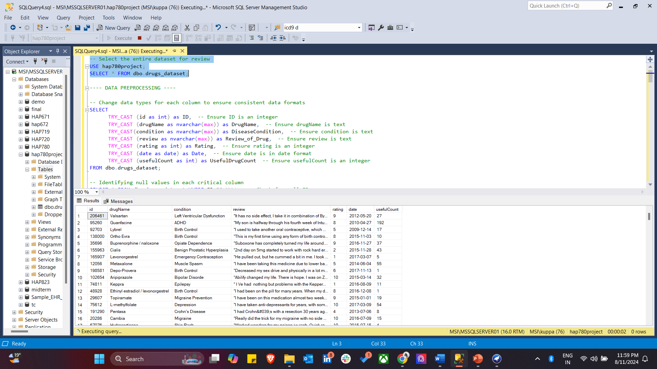

1. Data Type Standardization

**Ensure Consistent Data Formats:** Cast columns to appropriate data types (e.g., id as int, drugName as nvarchar(max), etc.).TRY_CAST is used to safely convert data types without causing errors.

*---- DATA PREPROCESSING ----*

*-- Change data types for each column to ensure consistent data formats*

*SELECT*

*TRY_CAST (id as int) as ID, -- Ensure ID is an integer*

*TRY_CAST (drugName as nvarchar(max)) as DrugName, -- Ensure drugName is text*

*TRY_CAST(condition as nvarchar(max)) as DiseaseCondition, -- Ensure condition is text*

*TRY_CAST (review as nvarchar(max)) as Review_of_Drug, -- Ensure review is text*

*TRY_CAST (rating as int) as Rating, -- Ensure rating is an integer*

*TRY_CAST (date as date) as Date, -- Ensure date is in date format*

*TRY_CAST (usefulCount as int) as UsefulDrugCount -- Ensure usefulCount is an integer*

*FROM dbo.drugs_dataset;*

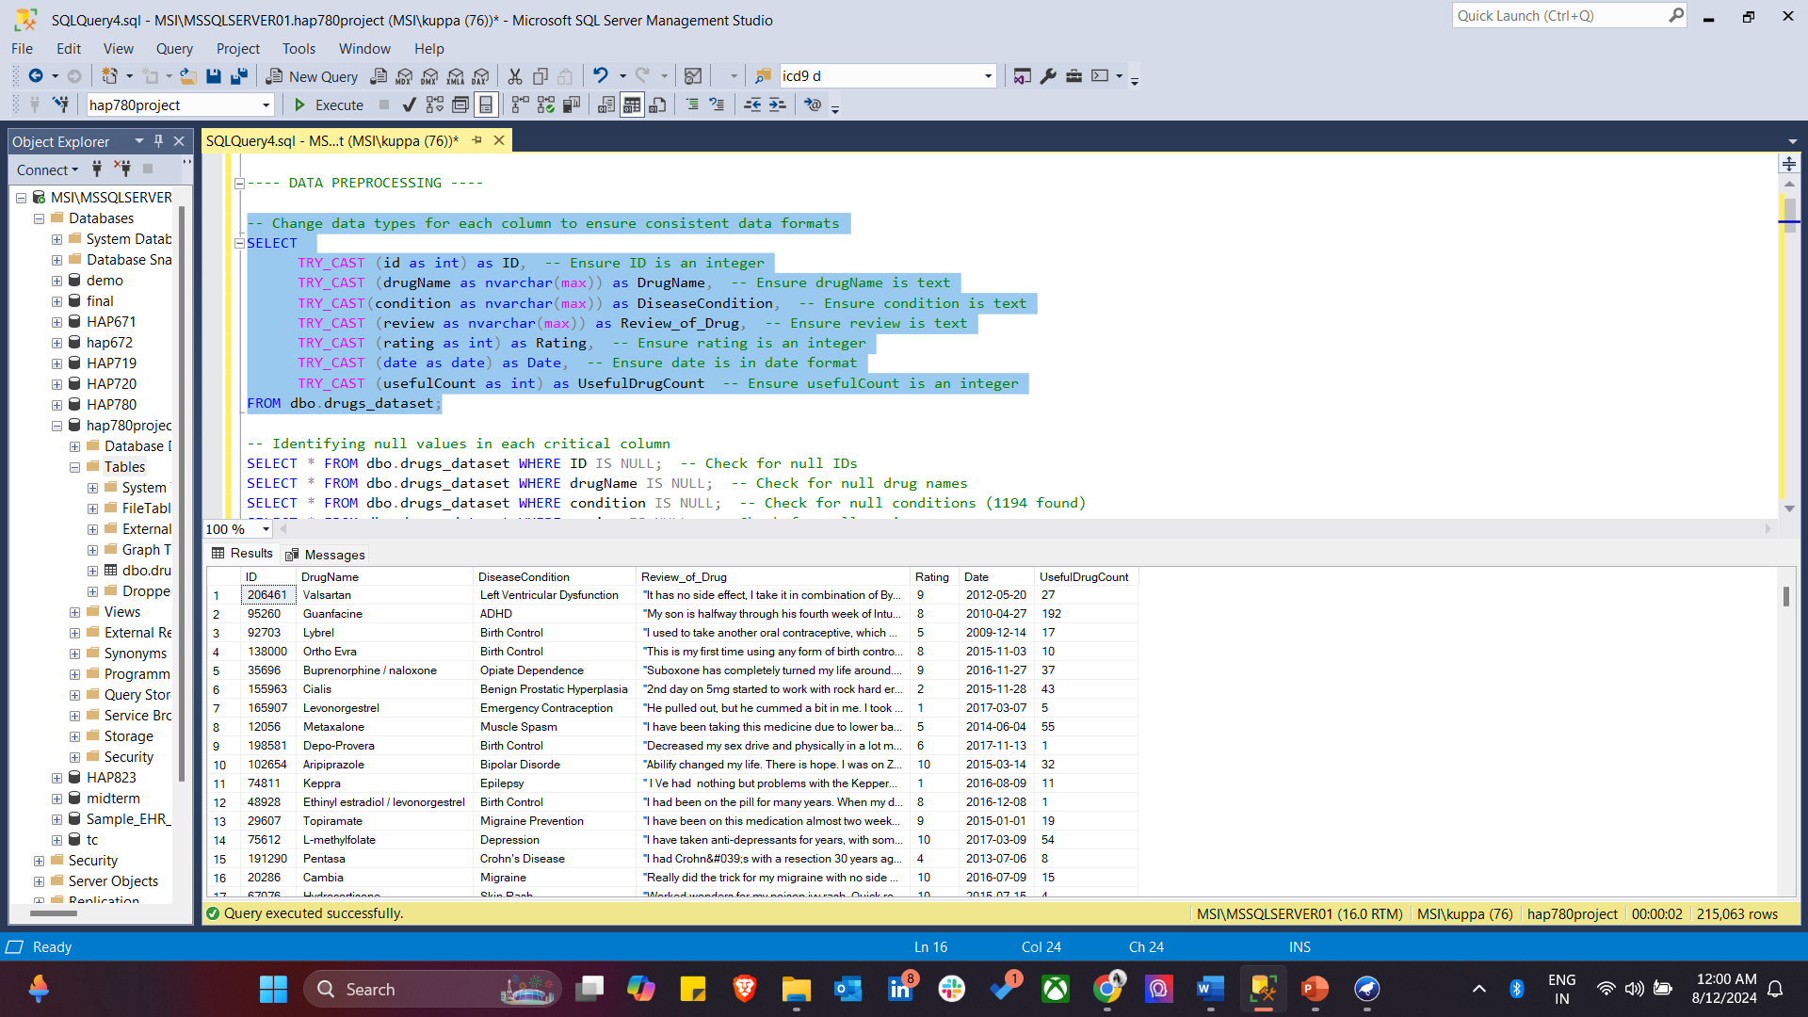

1. Null Value Identification and Handling

* Identify Null Values:
  + Check for nulls in critical columns like ID, drugName, condition, review, Rating, Date, and usefulCount.
* Remove Rows with Null Values:
  + Specifically remove rows where condition is null.

*-- Identifying null values in each critical column*

*SELECT * FROM dbo.drugs_dataset WHERE ID IS NULL; -- Check for null IDs*

*SELECT * FROM dbo.drugs_dataset WHERE drugName IS NULL; -- Check for null drug names*

*SELECT * FROM dbo.drugs_dataset WHERE condition IS NULL; -- Check for null conditions (1194 found)*

*SELECT * FROM dbo.drugs_dataset WHERE review IS NULL; -- Check for null reviews*

*SELECT * FROM dbo.drugs_dataset WHERE Rating IS NULL; -- Check for null ratings*

*SELECT * FROM dbo.drugs_dataset WHERE Date IS NULL; -- Check for null dates*

*SELECT * FROM dbo.drugs_dataset WHERE usefulCount IS NULL; -- Check for null usefulCount*

*-- Remove rows where the 'condition' column is null*

*DELETE FROM dbo.drugs_dataset WHERE condition IS NULL; -- 1194 rows removed*

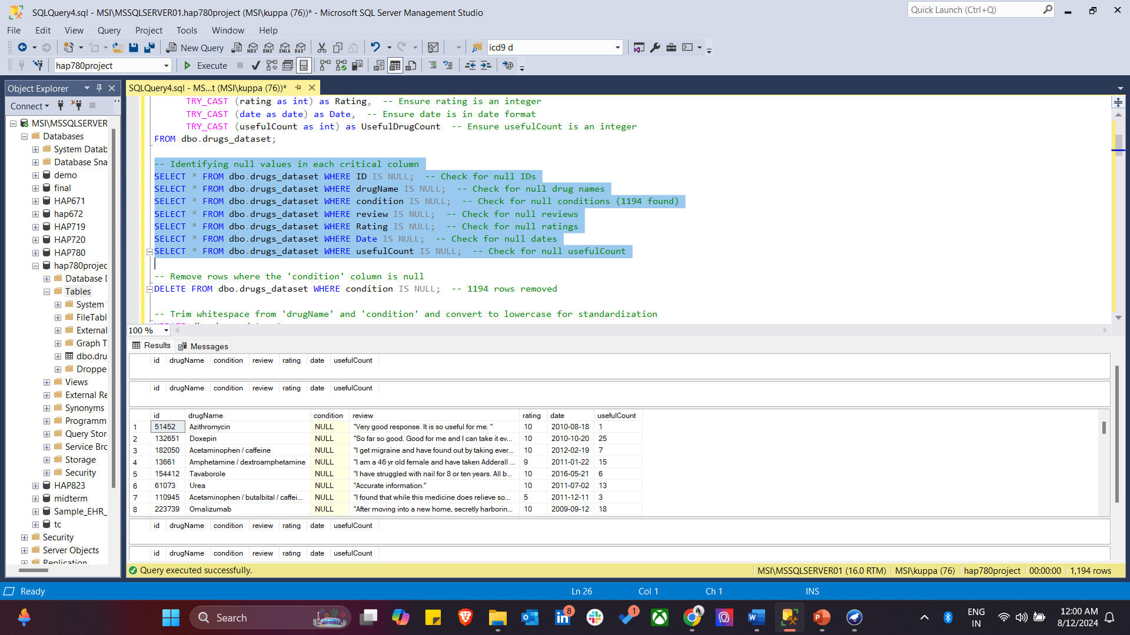

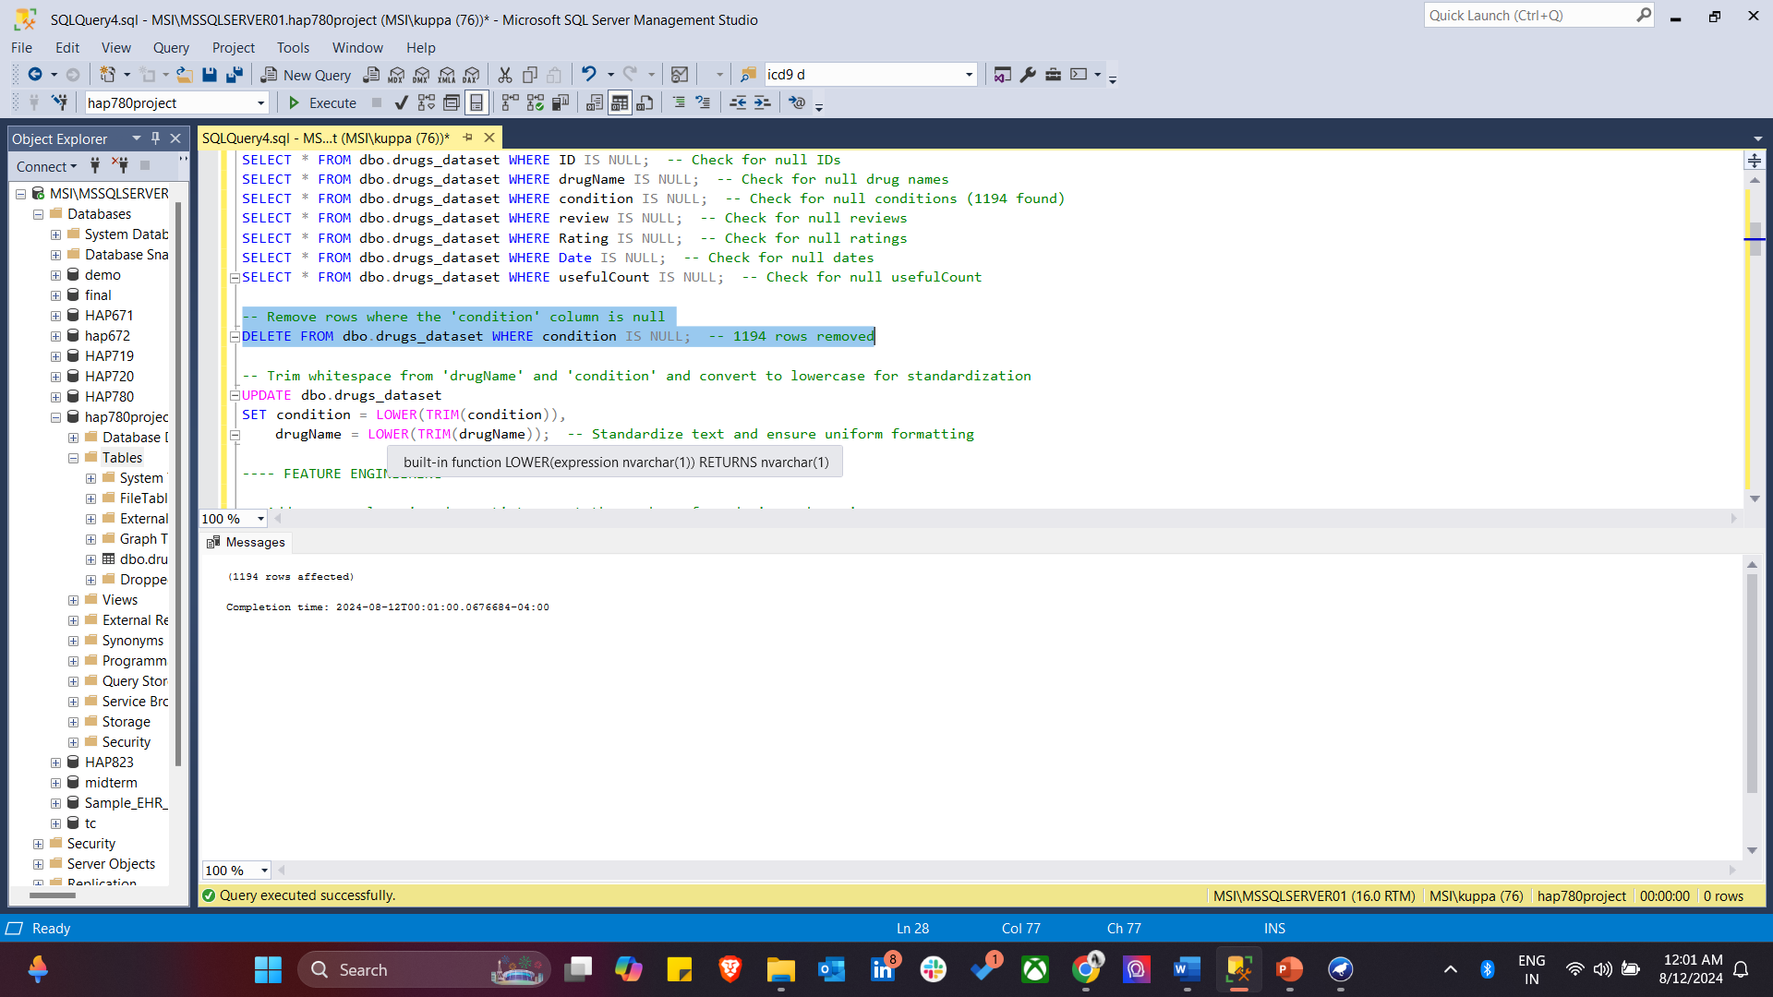

1. This SQL code snippet performs several data cleaning operations on the drugs_dataset table. First, it standardizes text data by trimming whitespace and converting the drugName and condition columns to lowercase for consistency. Next, it removes duplicate rows by keeping only the first occurrence of each unique id. Finally, it identifies outliers in the rating column by selecting records where the rating value is outside the expected range of 1 to 10, ensuring that the data remains within a valid and meaningful range for analysis.

*-- Trim whitespace from 'drugName' and 'condition' and convert to lowercase for standardization*

*UPDATE dbo.drugs_dataset*

*SET condition = LOWER(TRIM(condition)),*

*drugName = LOWER(TRIM(drugName)); -- Standardize text and ensure uniform formatting*

*-- Remove any duplicate rows based on the 'id' column*

*WITH CTE AS (*

*SELECT *,*

*ROW_NUMBER() OVER (PARTITION BY id ORDER BY id) AS rn*

*FROM dbo.drugs_dataset*

*)*

*DELETE FROM CTE WHERE rn > 1; -- Keep only the first occurrence of each ID*

*-- Identify any outliers in 'rating' where the value is not between 1 and 10*

*SELECT \**

*FROM dbo.drugs_dataset*

*WHERE rating < 1 OR rating > 10; -- Ensure ratings are within expected range*

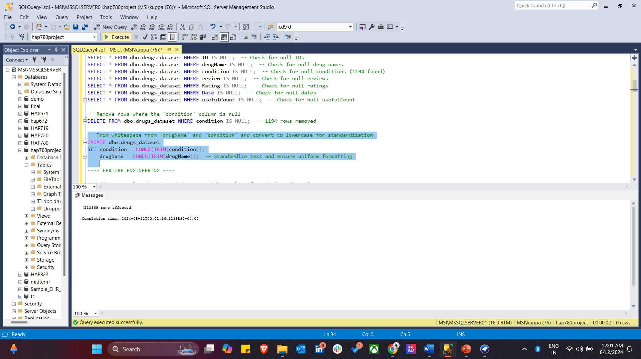

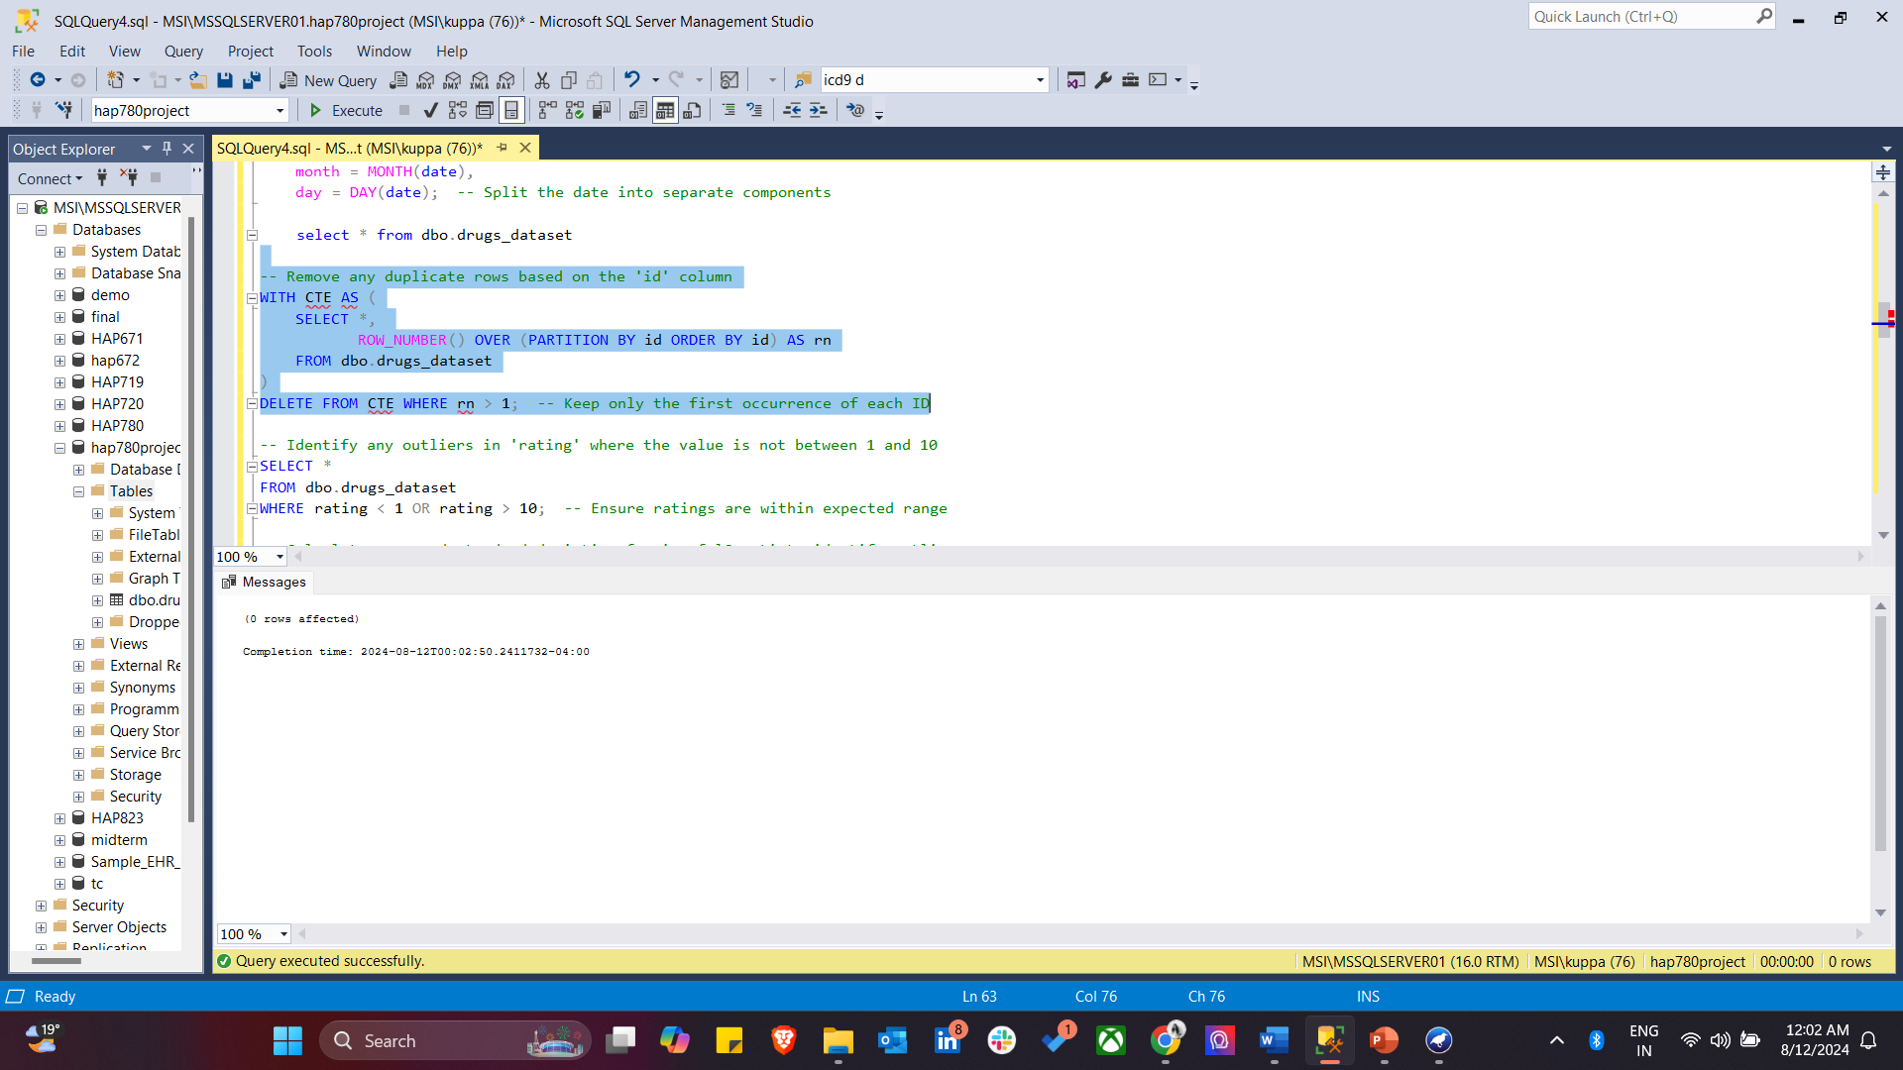

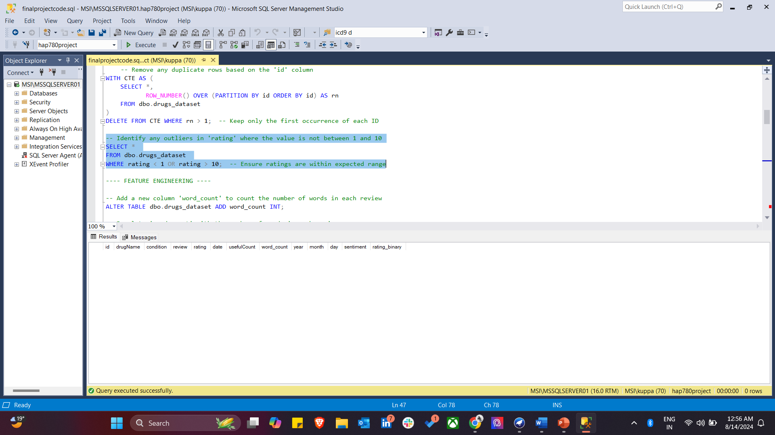

1. **Feature Engineering**

* **Add New Features:**
  + Calculate word count for each review and add a word_count column.
  + Split the date column into separate year, month, and day columns for more granular analysis.
* **Sentiment Analysis:**
  + Add and populate a sentiment column based on keywords in the review.

*---- FEATURE ENGINEERING ----*

*-- Add a new column 'word_count' to count the number of words in each review*

*ALTER TABLE dbo.drugs_dataset ADD word_count INT;*

*-- Populate 'word_count' with the number of words in each review*

*UPDATE dbo.drugs_dataset*

*SET word_count = LEN(review) - LEN(REPLACE(review, ' ', '')) + 1; -- Calculate word count*

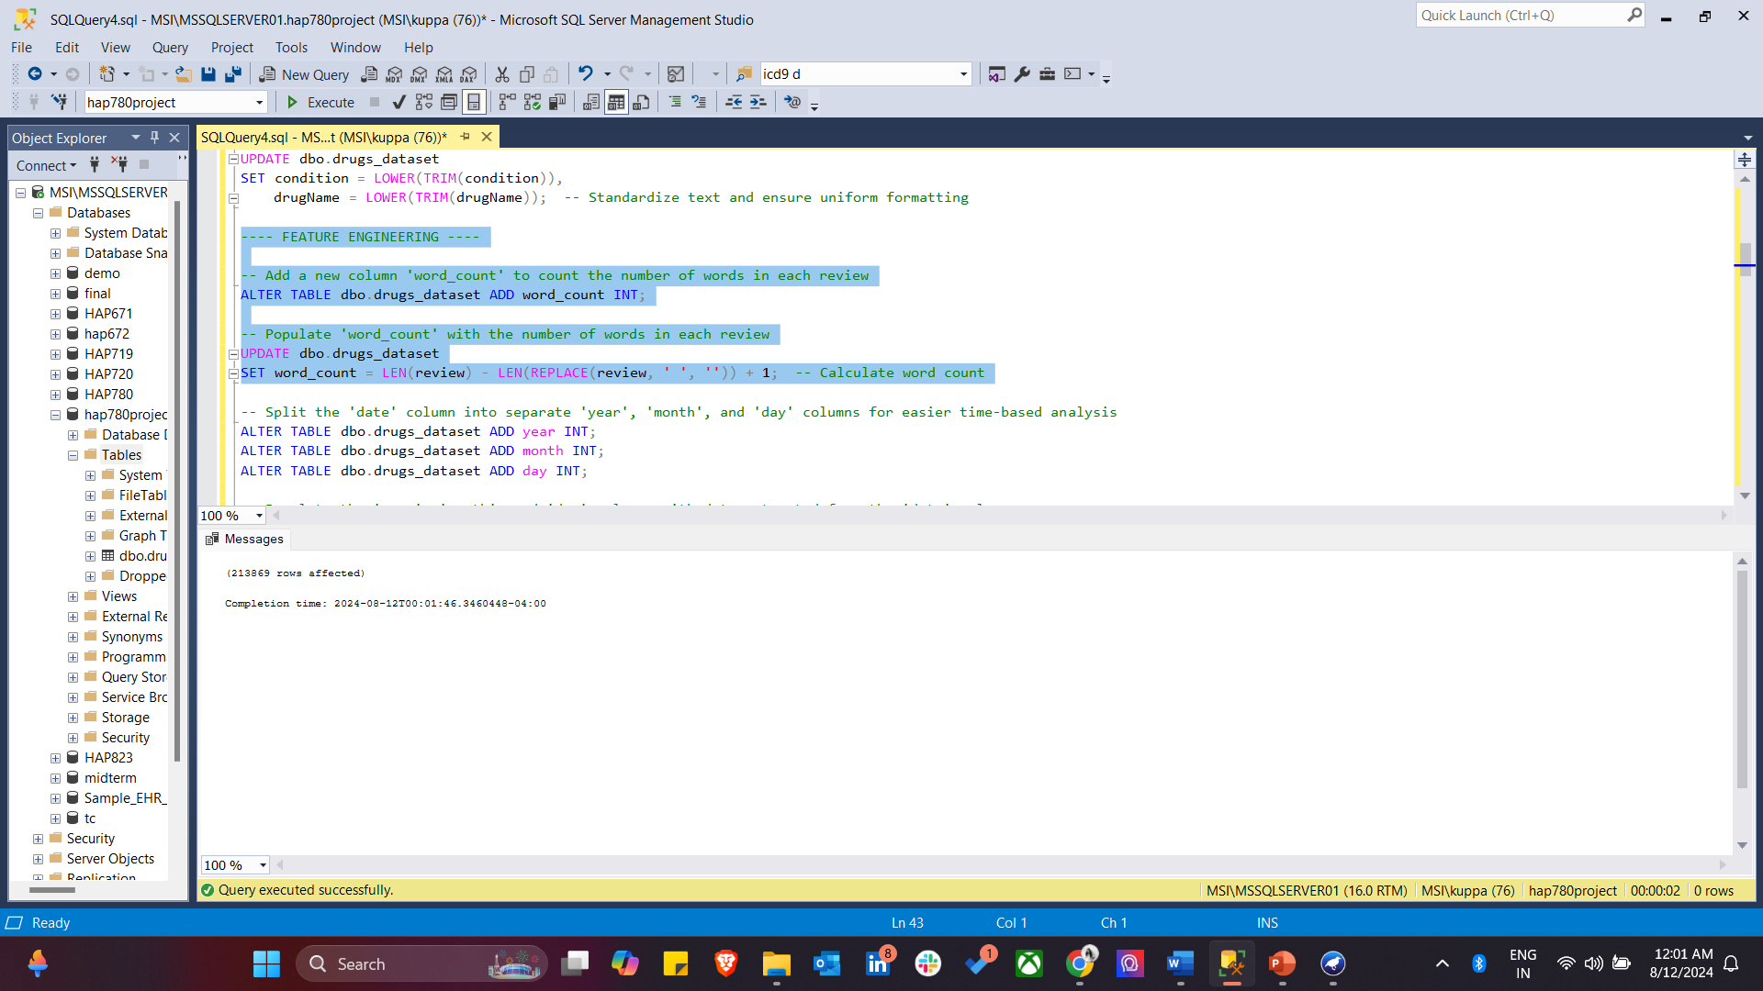

*-- Split the 'date' column into separate 'year', 'month', and 'day' columns for easier time-based analysis*

*ALTER TABLE dbo.drugs_dataset ADD year INT;*

*ALTER TABLE dbo.drugs_dataset ADD month INT;*

*ALTER TABLE dbo.drugs_dataset ADD day INT;*

*-- Populate the 'year', 'month', and 'day' columns with data extracted from the 'date' column*

*UPDATE dbo.drugs_dataset*

*SET year = YEAR(date),*

*month = MONTH(date),*

*day = DAY(date); -- Split the date into separate components*

*select * from dbo.drugs_dataset*

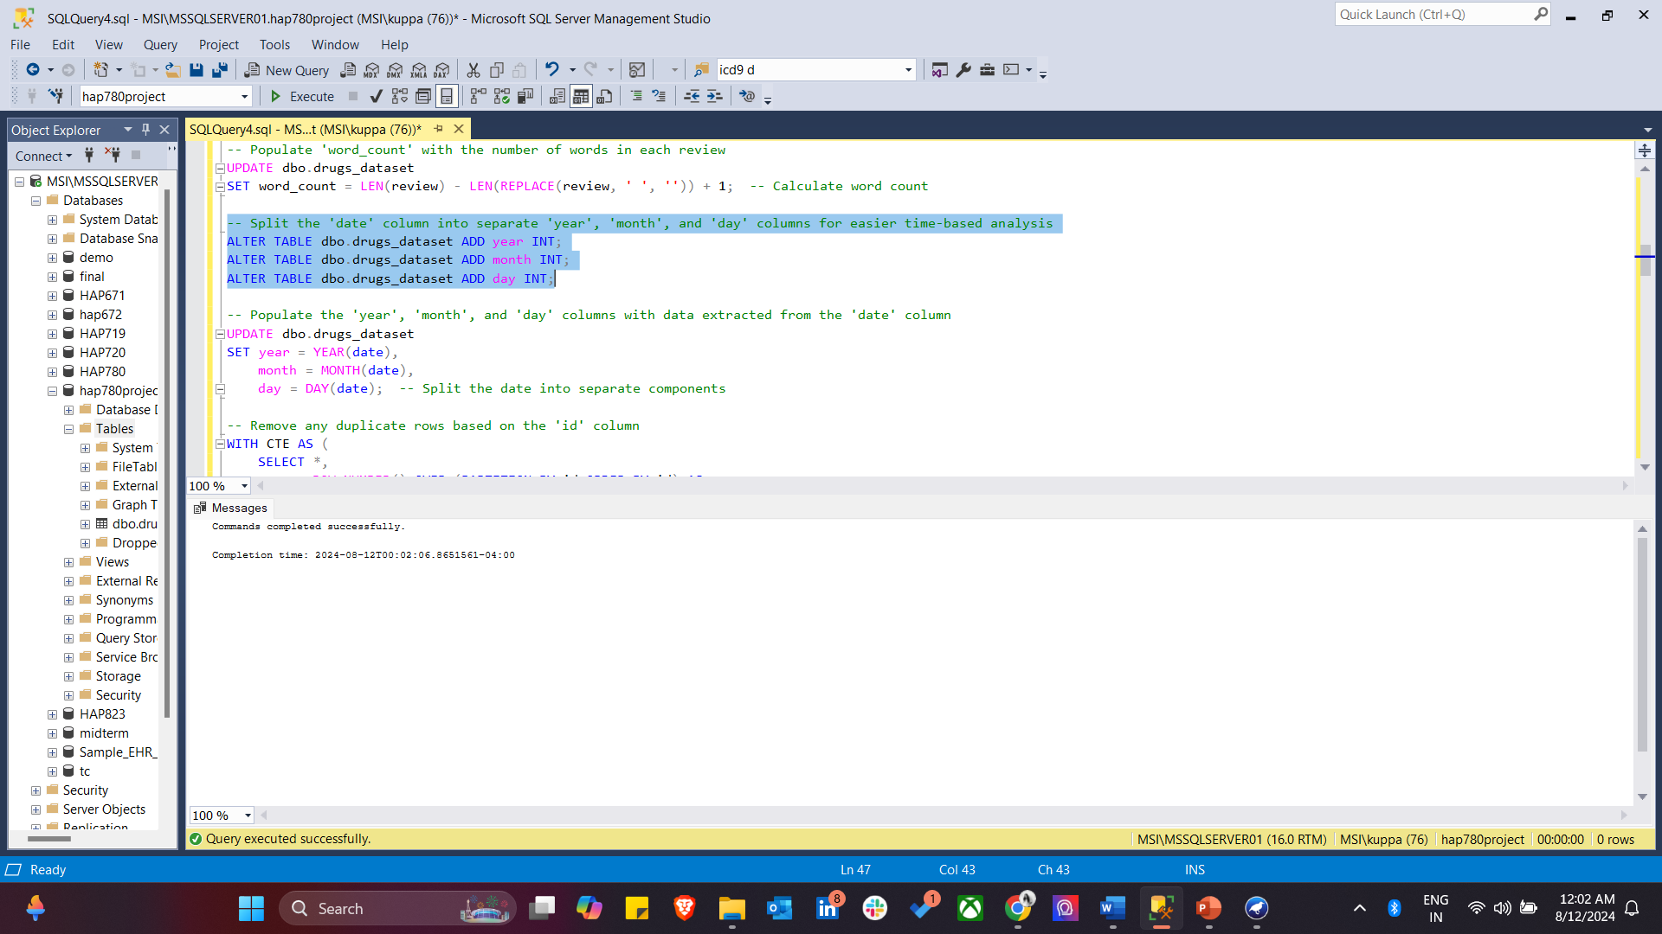

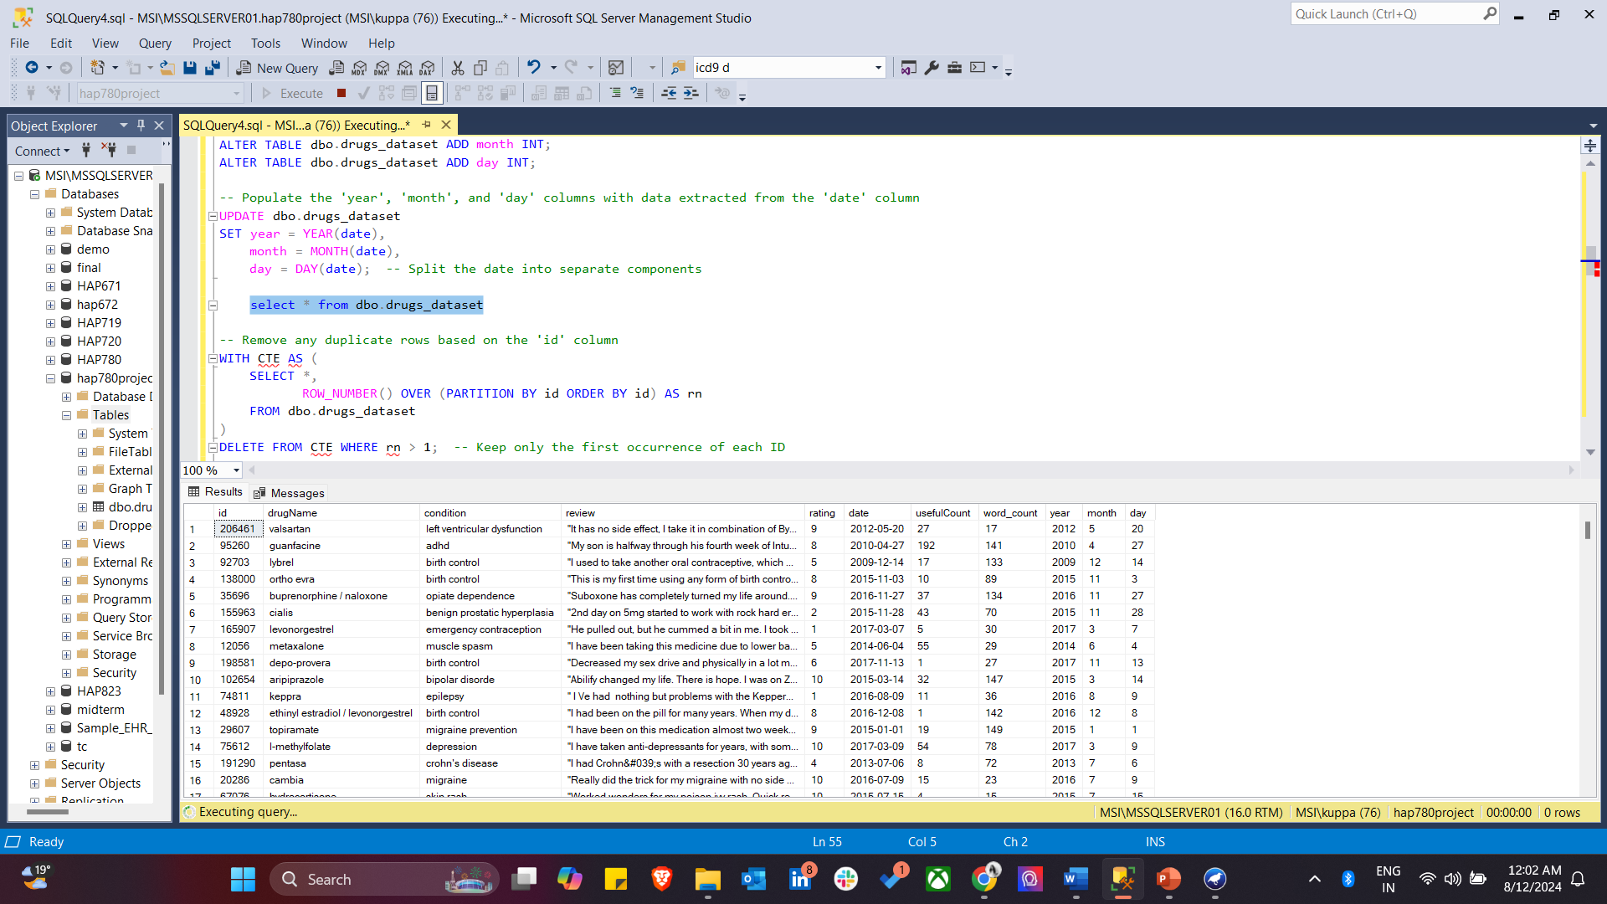

1. Outlier detection and removal in this project involve identifying and addressing anomalies in the dataset to ensure the accuracy of the analysis. First, rating outliers are detected by identifying values that fall outside the acceptable range of 1 to 10. Next, outliers in the usefulCount variable are identified by calculating the mean and standard deviation and applying the Z-Score method to pinpoint values that significantly deviate from the norm. These outliers are then removed to enhance the reliability of the subsequent analysis.

*-- Calculate mean and standard deviation for 'usefulCount' to identify outliers*

*WITH Stats AS (*

*SELECT*

*AVG(usefulCount) as MeanUsefulCount,*

*STDEV(usefulCount) as StdDevUsefulCount*

*FROM dbo.drugs_dataset*

*),*

*Outliers AS (*

*SELECT *,*

*(usefulCount - Stats.MeanUsefulCount) / Stats.StdDevUsefulCount as ZScore*

*FROM dbo.drugs_dataset, Stats*

*)*

*SELECT \**

*FROM Outliers*

*WHERE ABS(ZScore) > 3; -- Identify reviews where 'usefulCount' is an outlier*

*-- Delete outliers based on the calculated Z-Score*

*WITH Stats AS (*

*SELECT*

*AVG(usefulCount) as MeanUsefulCount,*

*STDEV(usefulCount) as StdDevUsefulCount*

*FROM dbo.drugs_dataset*

*),*

*Outliers AS (*

*SELECT *,*

*(usefulCount - Stats.MeanUsefulCount) / Stats.StdDevUsefulCount as ZScore*

*FROM dbo.drugs_dataset, Stats*

*)*

*DELETE FROM dbo.drugs_dataset*

*WHERE ID IN (SELECT ID FROM Outliers WHERE ABS(ZScore) > 3); -- Remove outliers ----(3929 rows affected)*

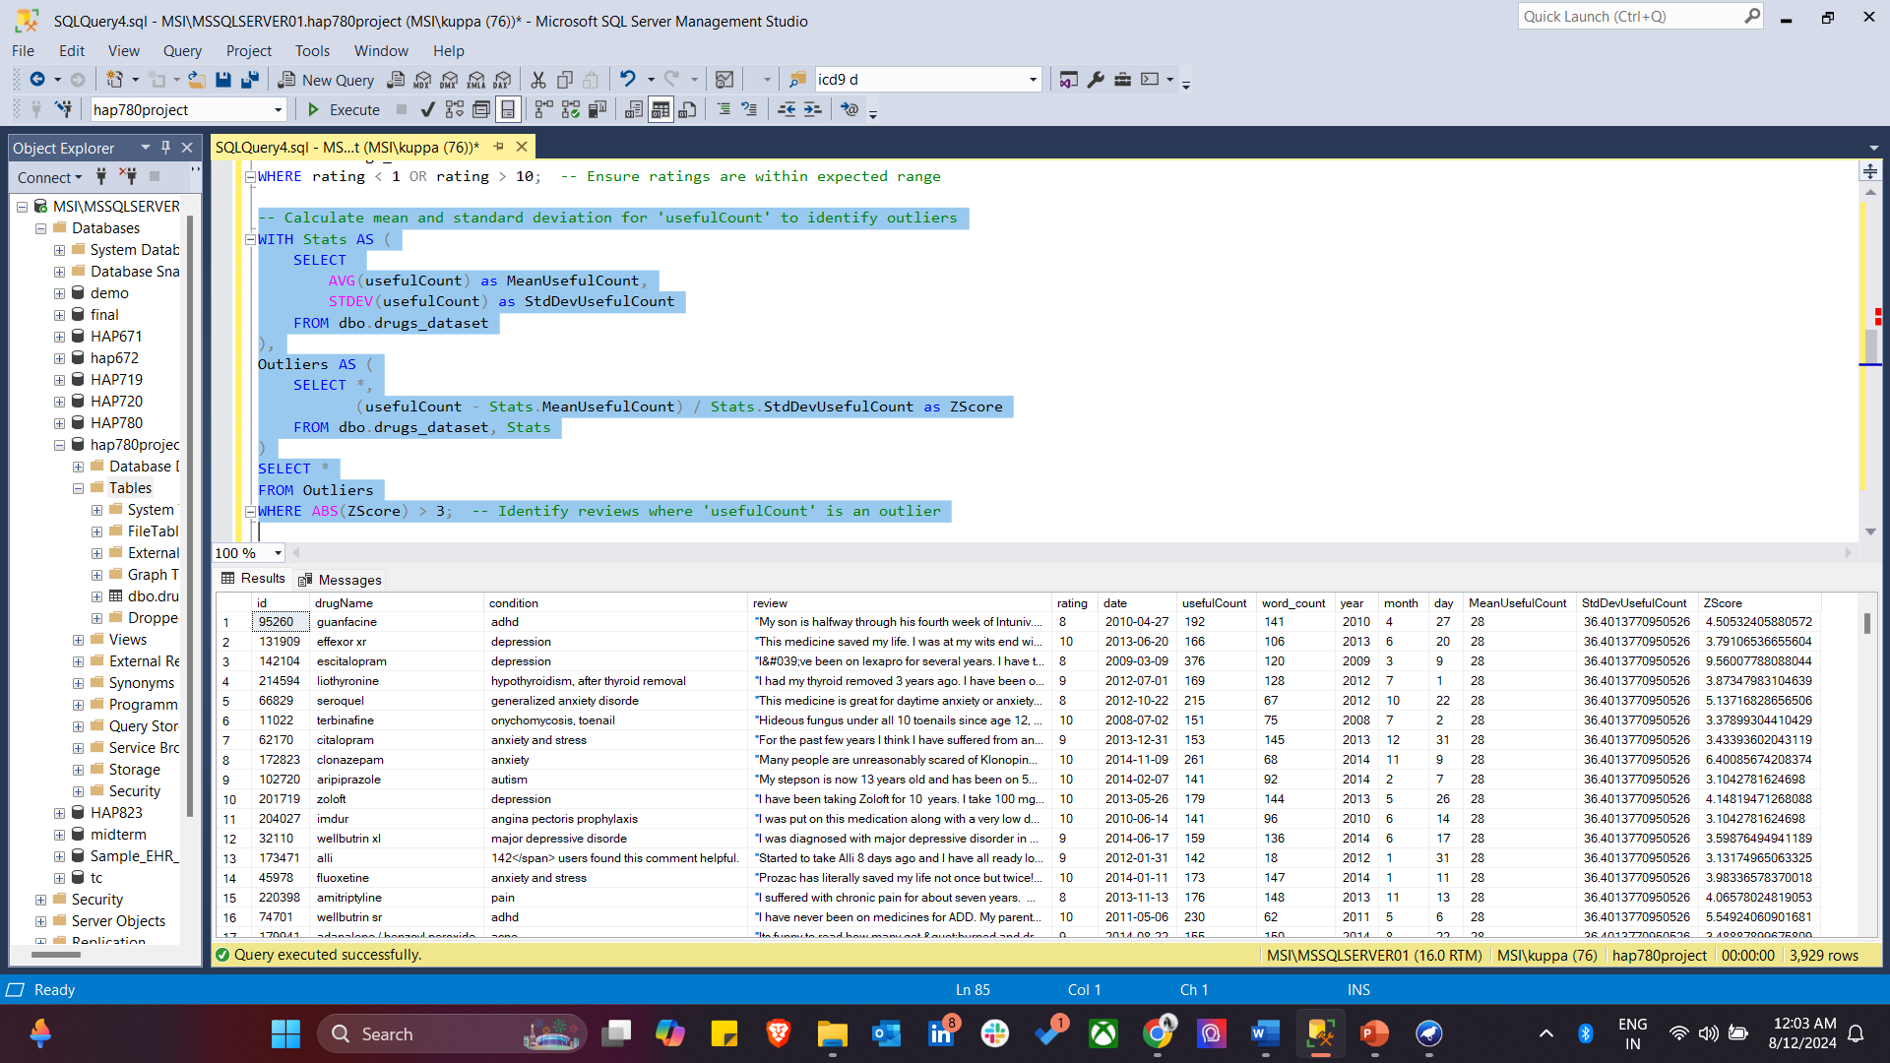

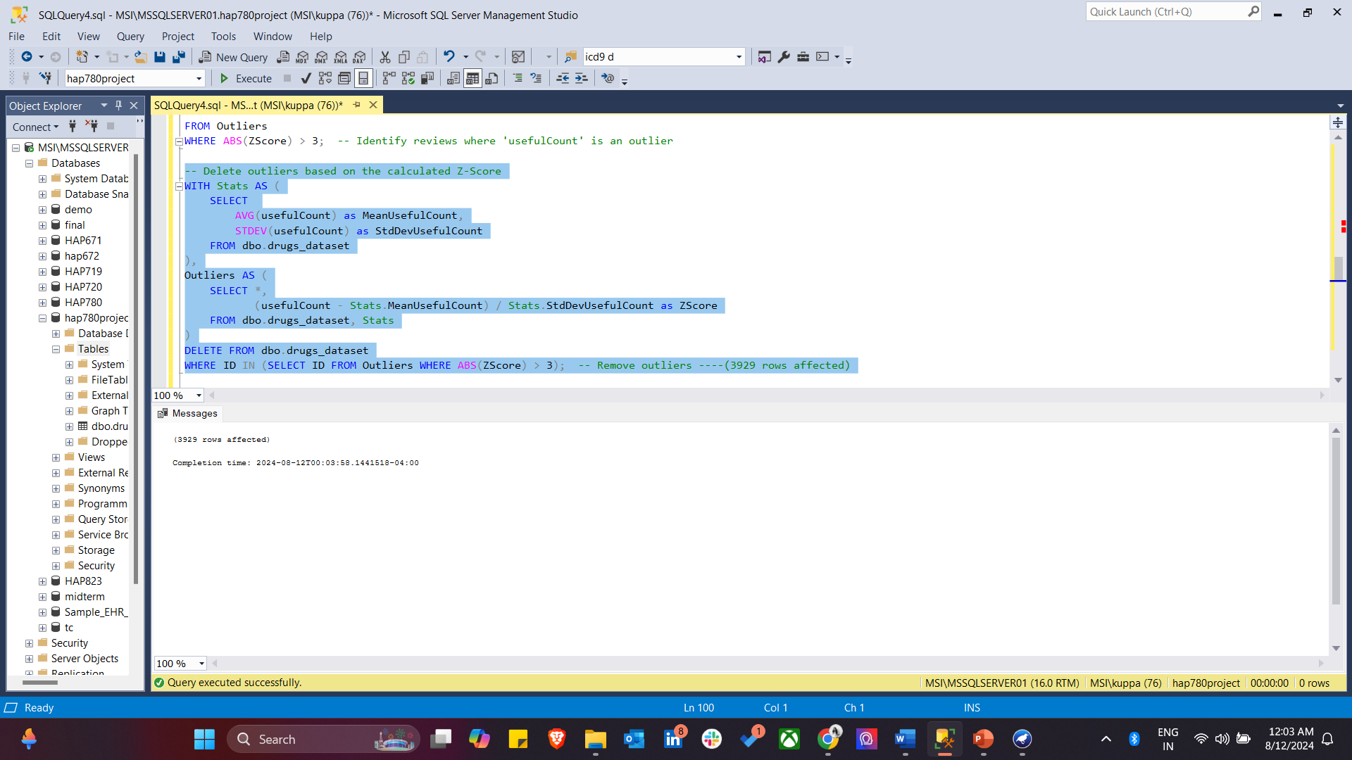

1. Check the number of rows left in the Dataset.

select COUNT(*) from dbo.drugs_dataset ---209940 rows

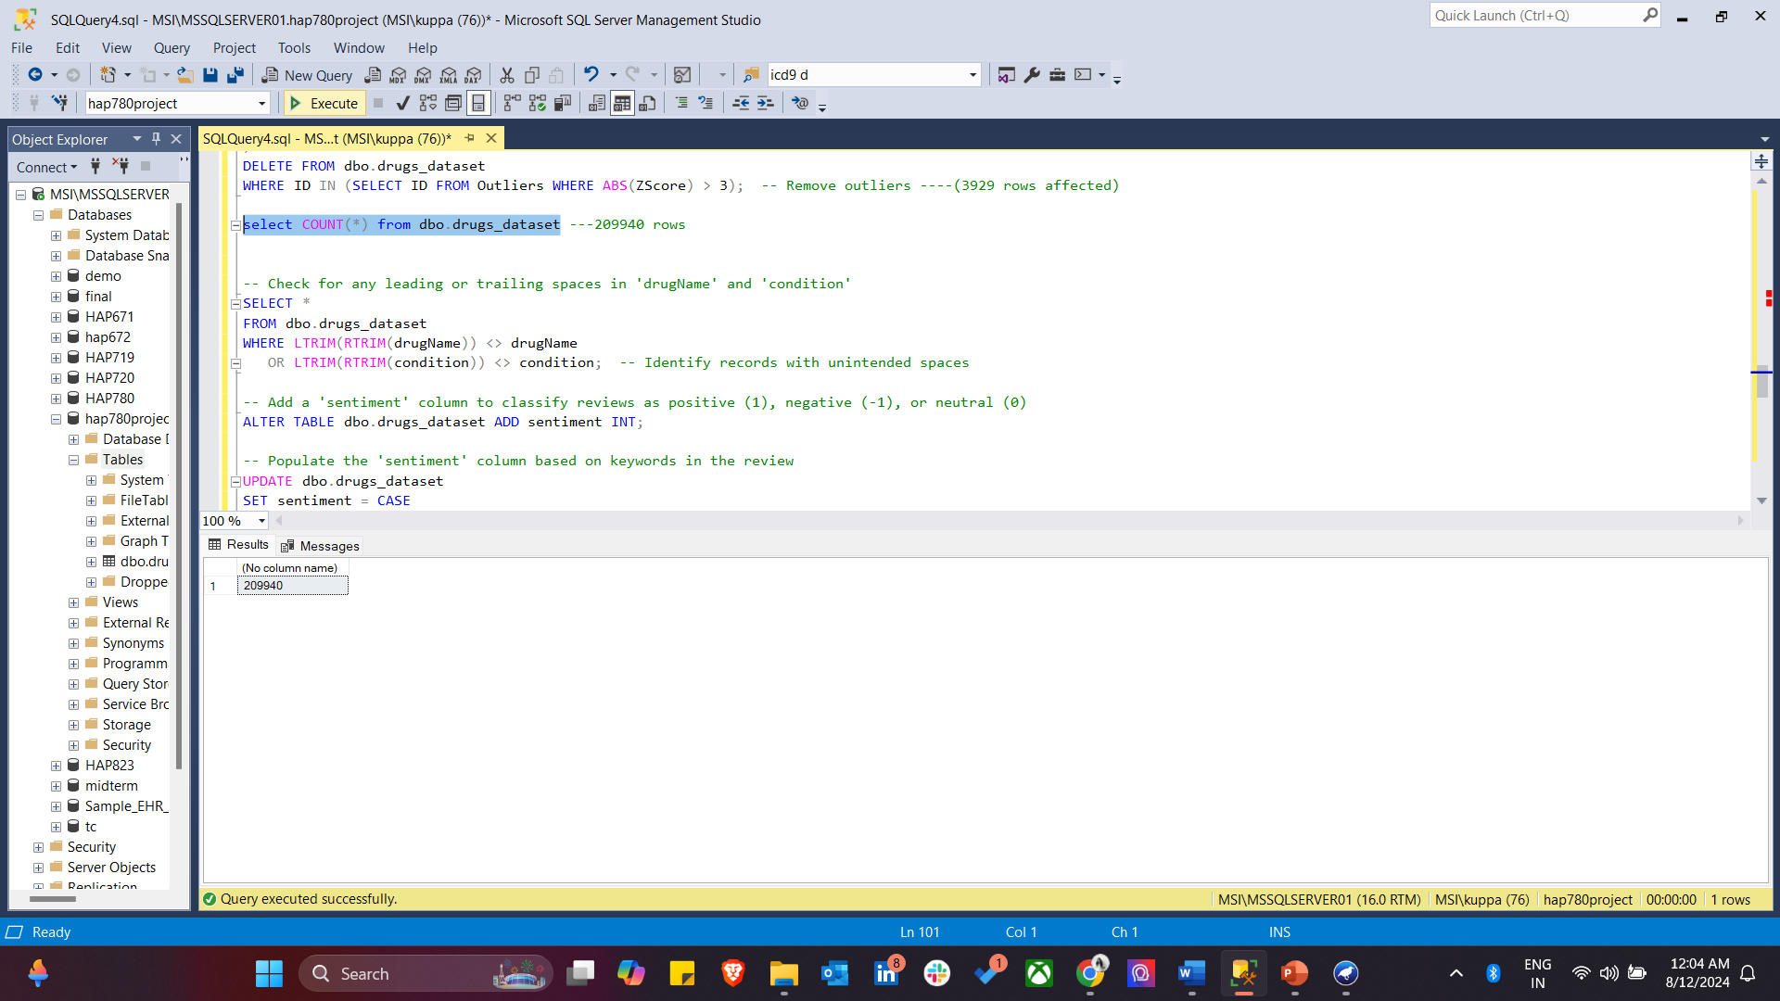

9) This identifies records in the drugs_dataset table where the drugName or condition columns contain unintended leading or trailing spaces. By trimming the spaces and comparing the results with the original values, the query flags any discrepancies, helping to ensure data consistency and accuracy.

*-- Check for any leading or trailing spaces in 'drugName' and 'condition'*

*SELECT \**

*FROM dbo.drugs_dataset*

*WHERE LTRIM(RTRIM(drugName)) <> drugName*

*OR LTRIM(RTRIM(condition)) <> condition; -- Identify records with unintended spaces*

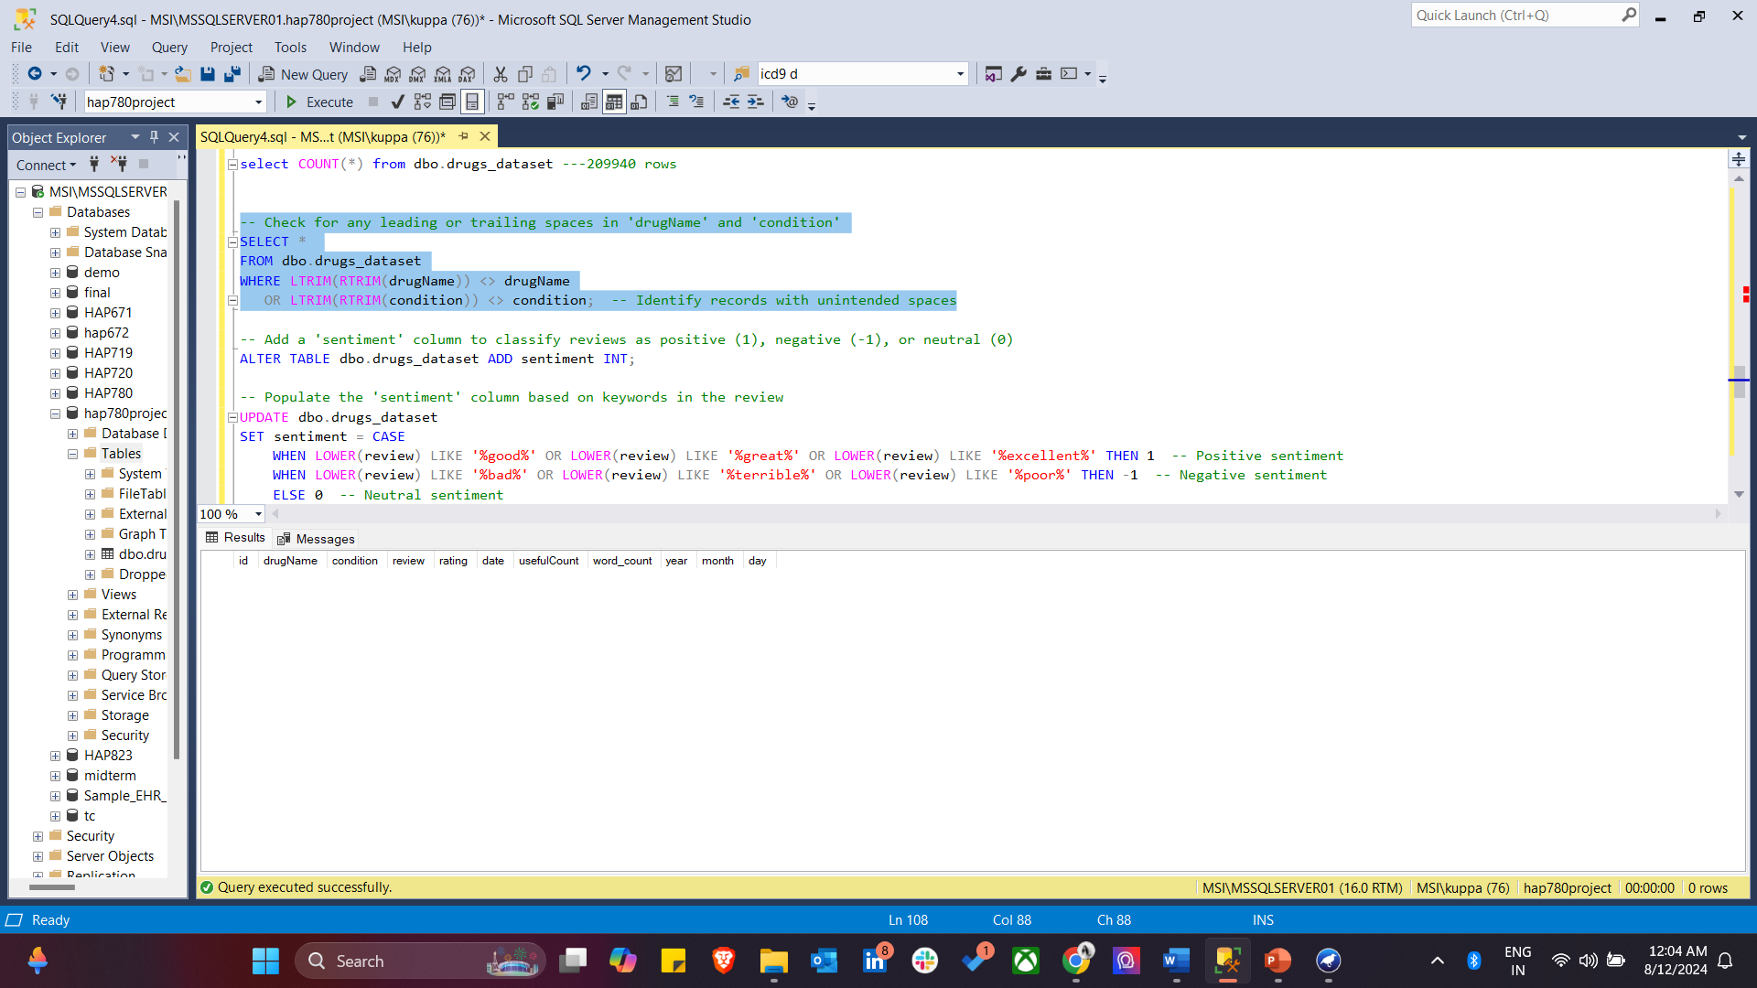

10) Here we add a new sentiment column to the drugs_dataset table to classify reviews as positive, negative, or neutral. The sentiment column is populated using an UPDATE statement that assigns a value of 1 for positive sentiment, -1 for negative sentiment, and 0 for neutral sentiment based on the presence of specific keywords in the review text. Finally, the script selects all records from the drugs_dataset table to review the results of the sentiment analysis.

*-- Add a 'sentiment' column to classify reviews as positive (1), negative (-1), or neutral (0)*

*ALTER TABLE dbo.drugs_dataset ADD sentiment INT;*

*-- Populate the 'sentiment' column based on keywords in the review*

*UPDATE dbo.drugs_dataset*

*SET sentiment = CASE*

*WHEN LOWER(review) LIKE '%good%' OR LOWER(review) LIKE '%great%' OR LOWER(review) LIKE '%excellent%' THEN 1 -- Positive sentiment*

*WHEN LOWER(review) LIKE '%bad%' OR LOWER(review) LIKE '%terrible%' OR LOWER(review) LIKE '%poor%' THEN -1 -- Negative sentiment*

*ELSE 0 -- Neutral sentiment*

*END;*

*-- Check the table after sentiment analysis*

*SELECT * FROM dbo.drugs_dataset;*

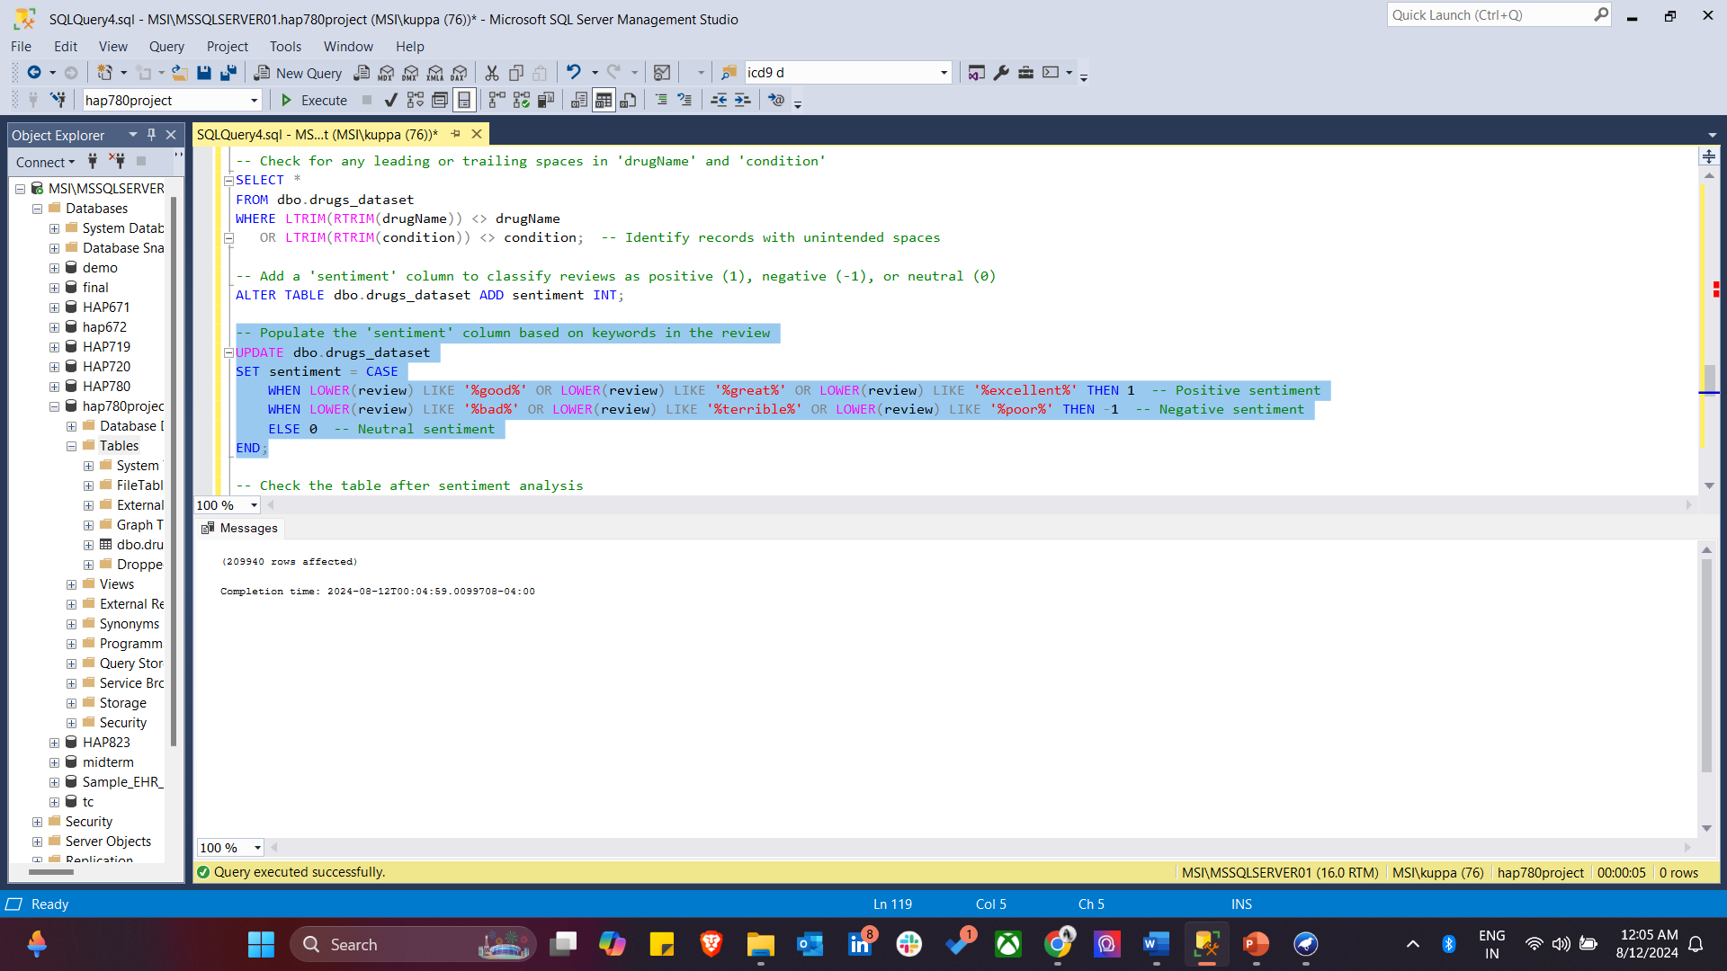

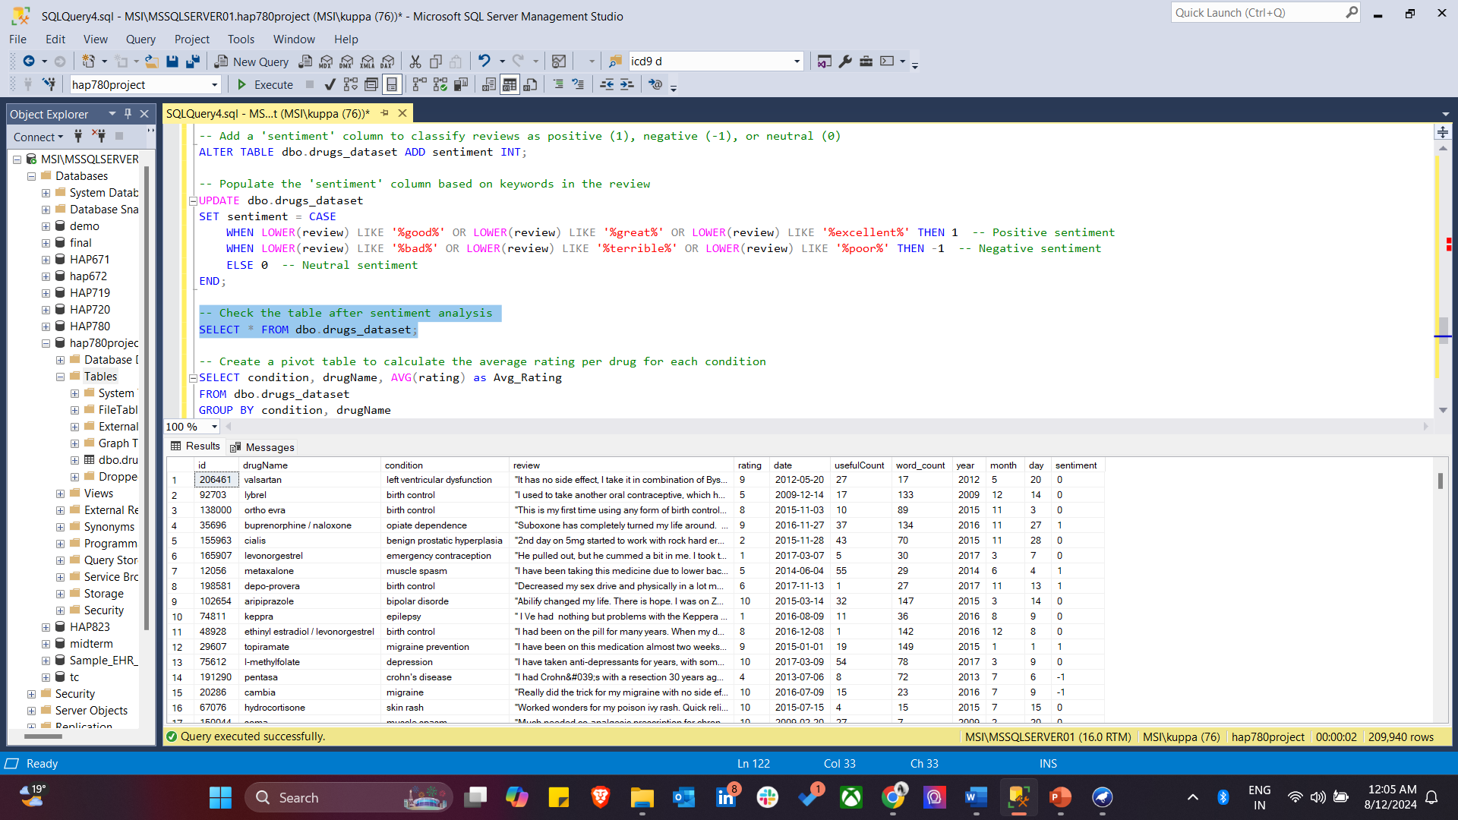

11) This step simplifies the rating data into binary categories, making it easier to analyze and use in predictive models. This SQL script performs binarization on the rating column in the drugs_dataset table by adding a new rating_binary column. The rating_binary column classifies ratings as either high (1) or low (0). Specifically, if the rating is 7 or higher, the rating_binary column is set to '1'; otherwise, it is set to '0'.

*---- BINARIZATION ----*

*-- Add a binary column 'rating_binary' to classify ratings as high (1) or low (0)*

*ALTER TABLE dbo.drugs_dataset ADD rating_binary VARCHAR(10);*

*-- Populate 'rating_binary' based on the 'rating' column (1 if rating >= 7, else 0)*

*UPDATE dbo.drugs_dataset*

*SET rating_binary = CASE*

*WHEN rating >= 7 THEN '1' -- High rating*

*ELSE '0' -- Low rating*

*END;*

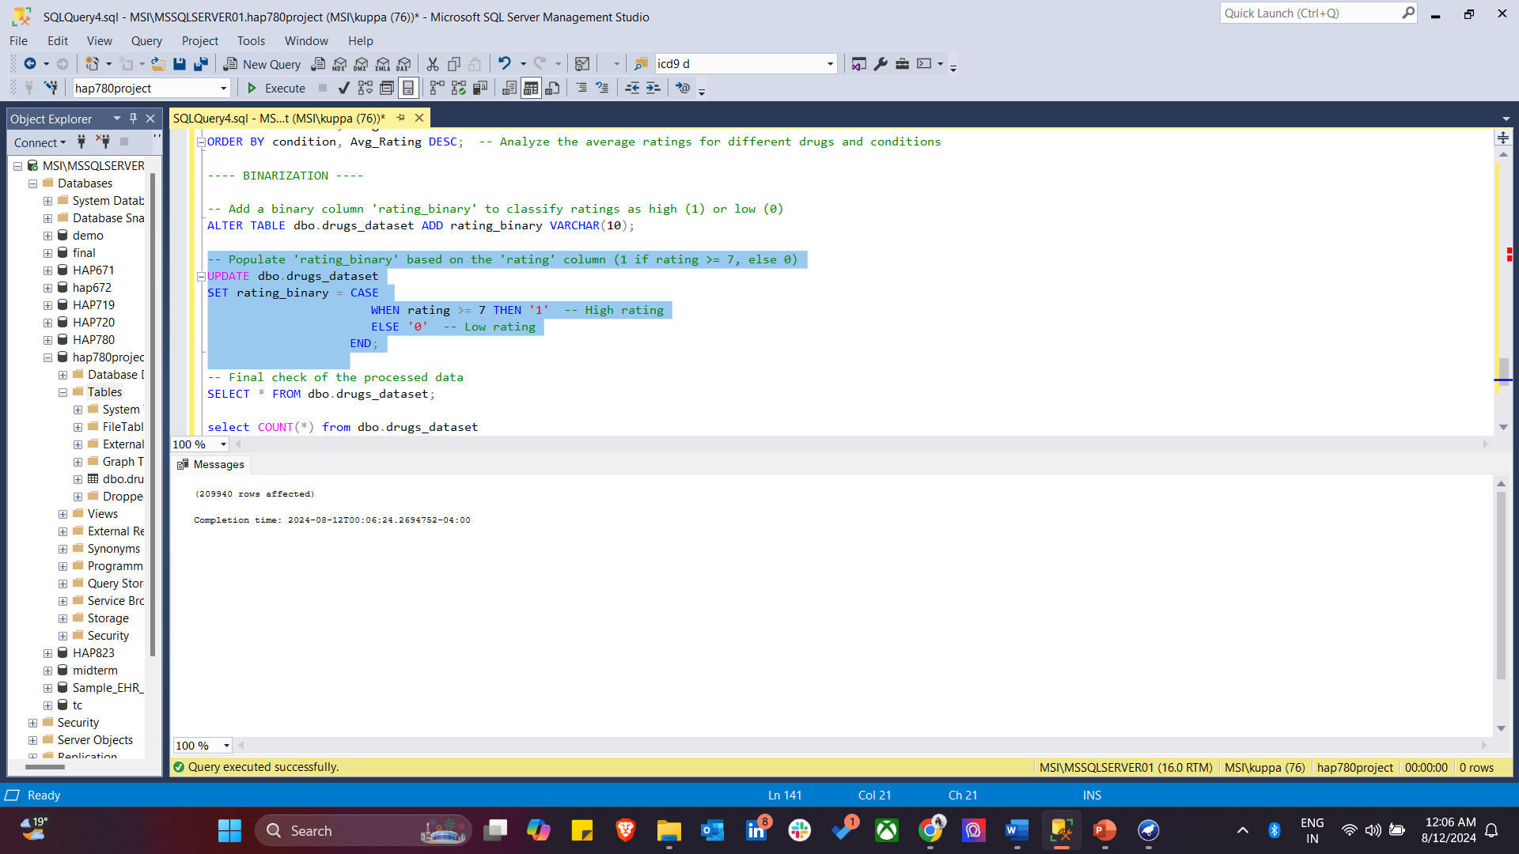

*-- Final check of the processed data*

*SELECT * FROM dbo.drugs_dataset;*

*select COUNT(*) from dbo.drugs_dataset*

*select top 1500 * from dbo.drugs_dataset*

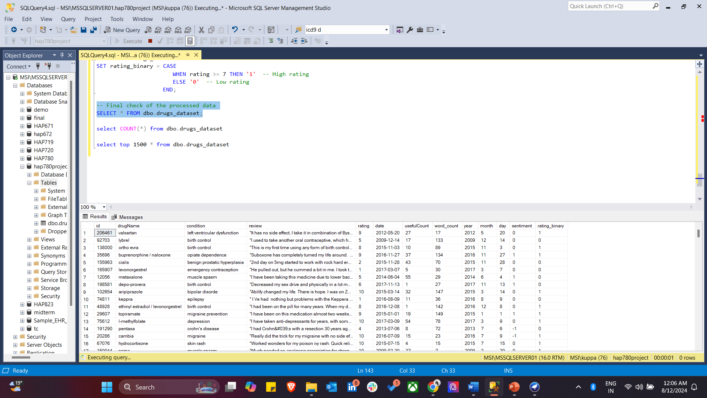

Below is the csv file (a subset of the original dataset) contains 1500 instances that is exported from SSMS and uploaded into Weka Software for data analysis.

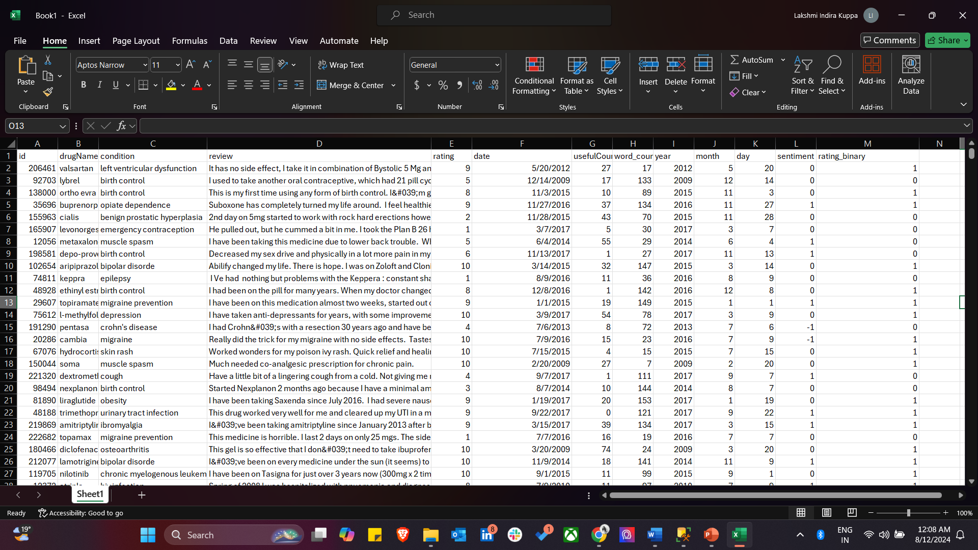

**WEKA SOFTWARE**

1. WEKA's preprocessing stages: visualizing attribute distributions, applying filters, converting numeric to nominal data, and finalizing the dataset, ensuring readiness for effective machine learning analysis.

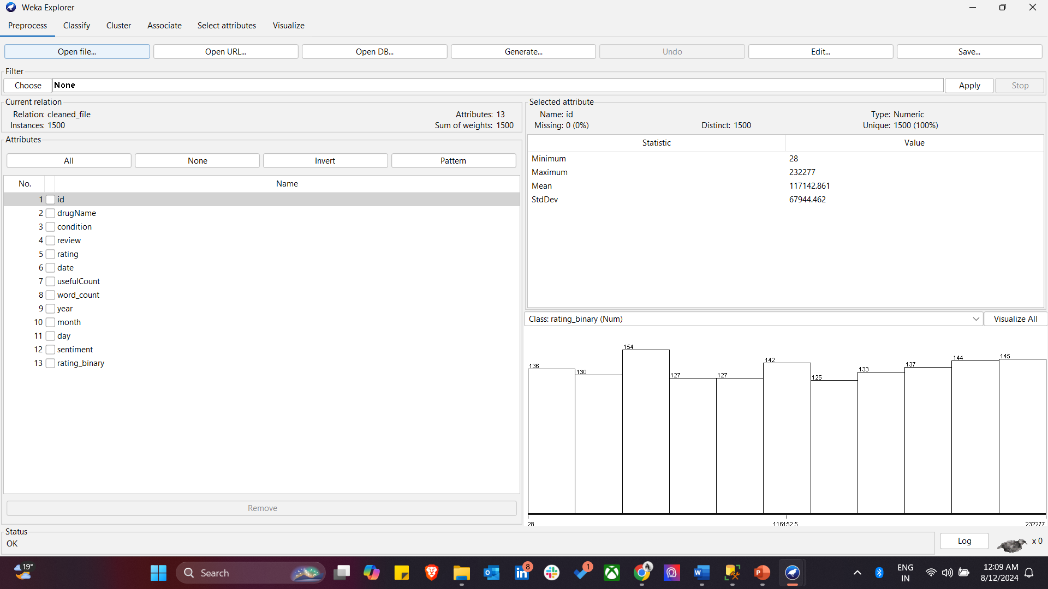

1. For preprocessing in Weka, I have used Numeric -to- Nominal and converted all the relevant attributes to nominal type. I have normalized the attributes for uniformity and consistency.

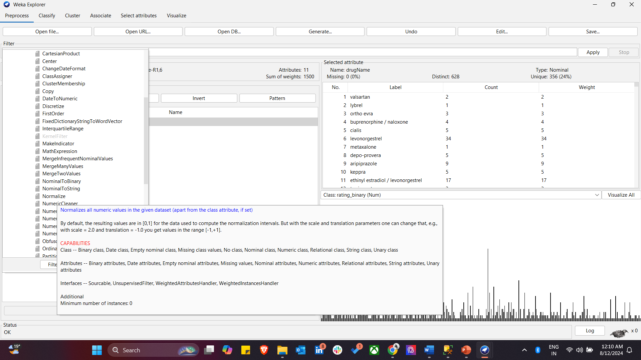

This is the visual representation of all the attributes in Weka.

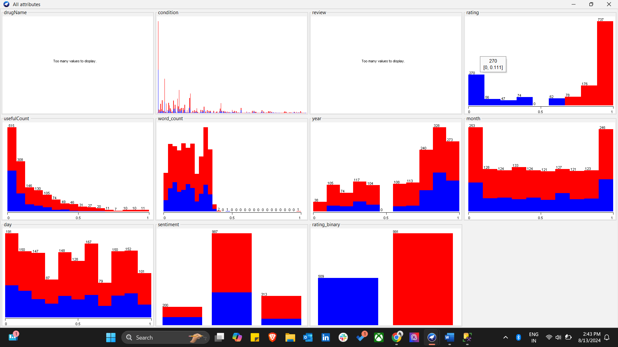

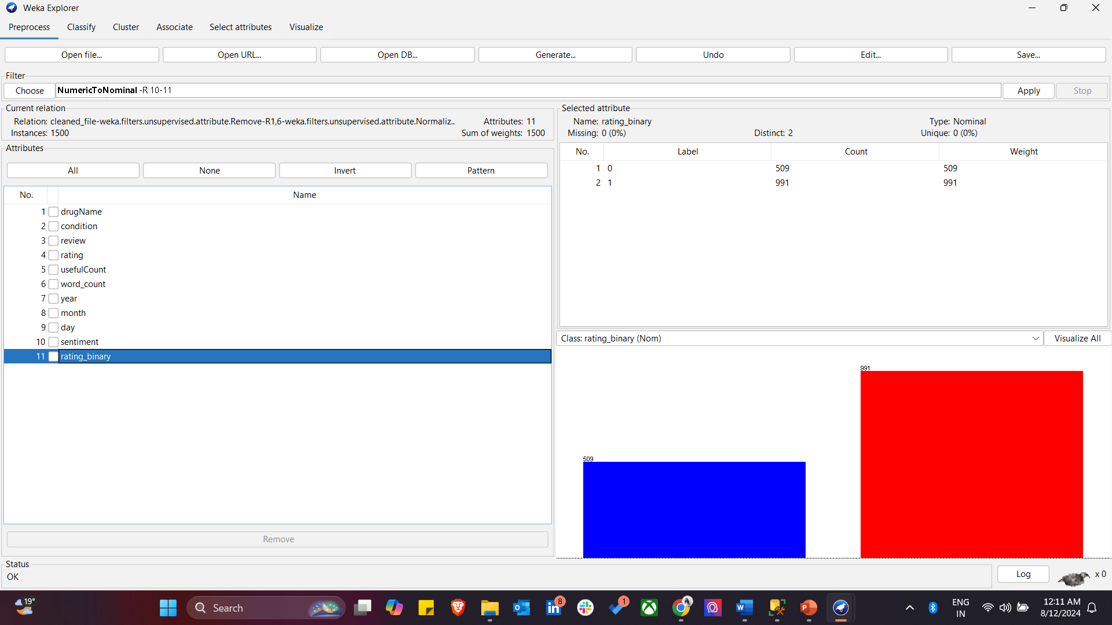

1. Below shows the WEKA Explorer's attribute selection process, using the Information Gain Attribute Evaluator combined with the Ranker method. It ranks attributes based on their relevance to the target class (rating_binary), with review and rating identified as the most significant predictors. This step helps in identifying the most influential features for the model, enhancing its accuracy and efficiency.

Here, we observe that attributes, ‘review’ and ‘rating’ are most influential features.

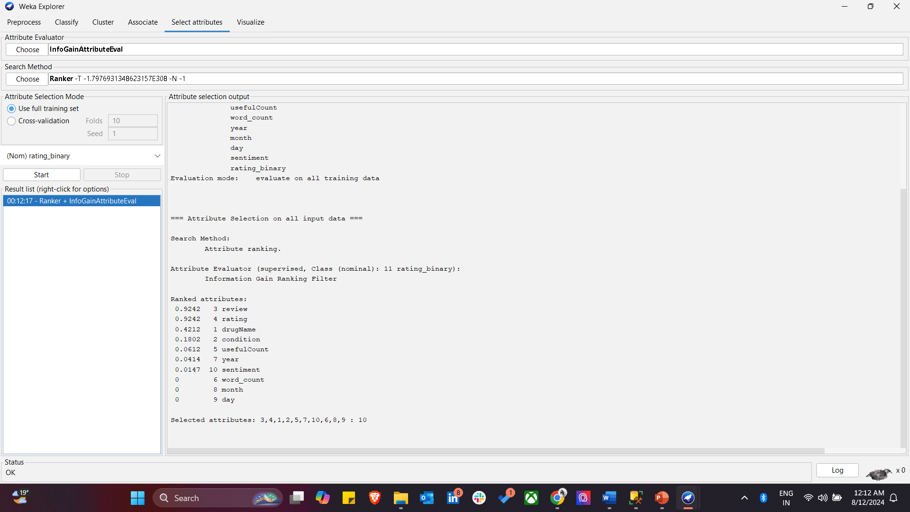

1. Results of a logistic regression model applied in WEKA using cross-validation-

The model achieved an accuracy of 95.47%, correctly classifying 1432 out of 1500 instances. The confusion matrix and detailed accuracy metrics, such as precision, recall, and ROC area, indicate strong model performance, particularly in distinguishing between the two classes in the rating_binary attribute.

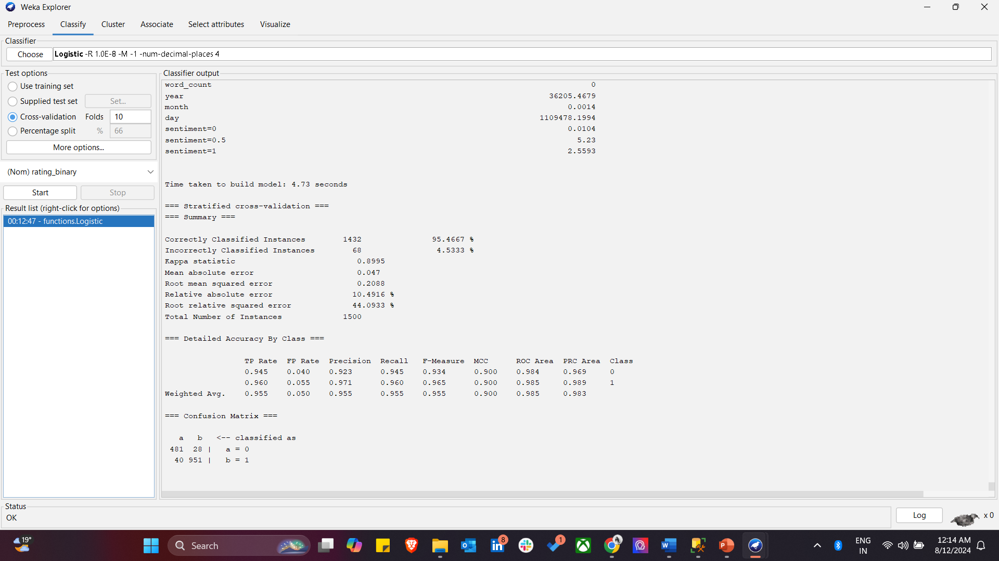

1. Results of a J48 decision tree model applied in WEKA with cross-validation-

The model achieved perfect accuracy, correctly classifying all 1500 instances. The confusion matrix indicates no misclassifications, with a precision, recall, and F-measure of 1.000 for both classes. The model's simplicity is reflected in its small tree size, with only two leaves and three nodes, making it highly efficient for this dataset.

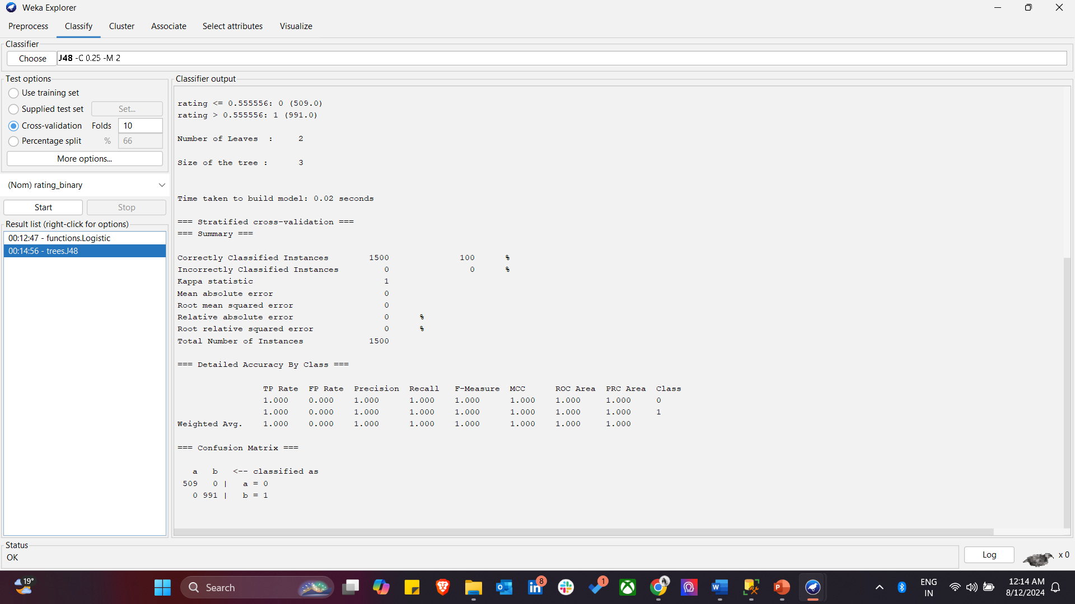

1. Results of a Random Forest model run in WEKA using cross-validation-

The model correctly classified 1409 out of 1500 instances, achieving an accuracy of 93.93%. The confusion matrix shows that the model is highly accurate, particularly for classifying the positive class (rating_binary = 1). The detailed accuracy metrics, including precision, recall, and F-measure, indicate that the model performs well across both classes, making it a robust choice for this classification task.

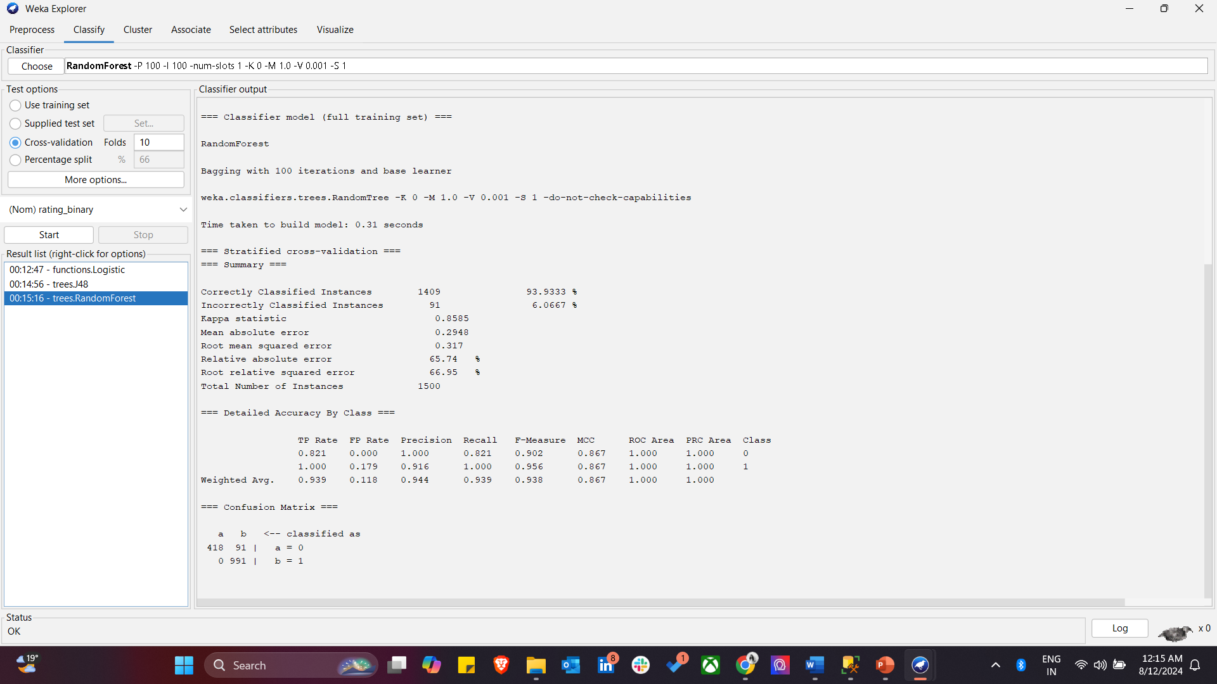

1. Results of a Naive Bayes classifier applied in WEKA using cross-validation-

The model achieved an accuracy of 98.07%, correctly classifying 1471 out of 1500 instances. The confusion matrix shows minimal misclassifications, with strong performance metrics such as precision, recall, and F-measure. The Naive Bayes classifier, known for its simplicity and efficiency, performed exceptionally well on this dataset, making it a reliable model for this binary classification task.

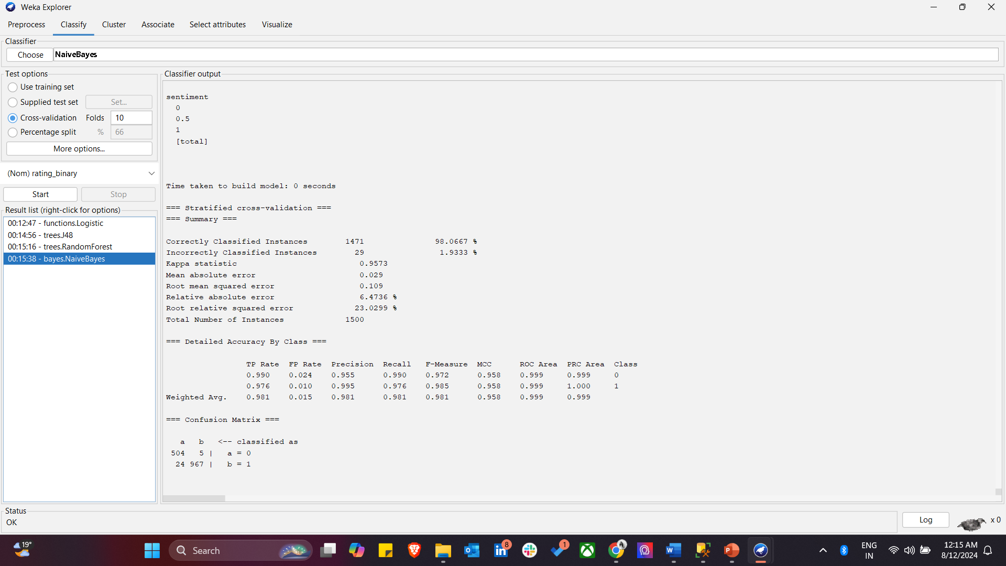

1. Results of an SMO (Support Vector Machine) model applied in WEKA using cross-validation-

The model achieved an accuracy of 99.27%, correctly classifying 1489 out of 1500 instances. The confusion matrix indicates very few misclassifications, with high precision, recall, and F-measure across both classes. The model’s strong performance metrics, including a near-perfect Kappa statistic, demonstrate its effectiveness in handling the classification task.

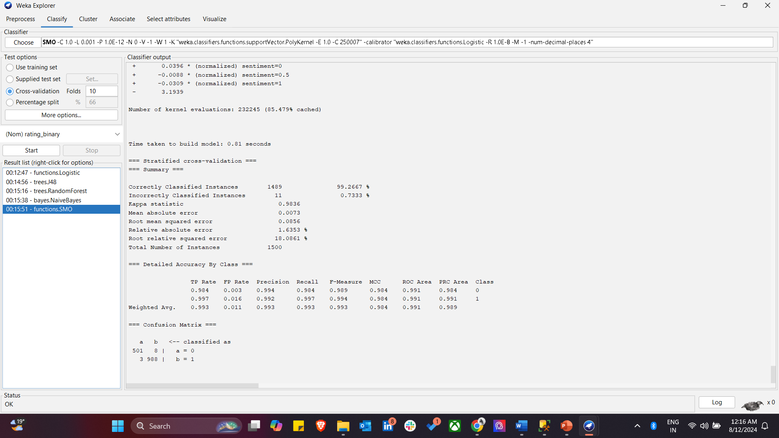

1. I have used five different classification algorithms for the dataset. Below is the overall summary of the relevant values for each classification algorithm.

|  |  |  |  |  |  |  |  |  |  |
| --- | --- | --- | --- | --- | --- | --- | --- | --- | --- |
| **Model** | **Correctly Classified Instances (%)** | **Precision (Class 0)** | **Precision (Class 1)** | **Recall (Class 0)** | **Recall (Class 1)** | **F-Measure (Class 0)** | **F-Measure (Class 1)** | **ROC Area (Class 0)** | **ROC Area (Class 1)** |
| **Logistic Regression** | 95.47 | 0.923 | 0.971 | 0.945 | 0.960 | 0.934 | 0.965 | 0.984 | 0.985 |
| **J48 Decision Tree** | 100 | 1.000 | 1.000 | 1.000 | 1.000 | 1.000 | 1.000 | 1.000 | 1.000 |
| **Random Forest** | 93.93 | 0.821 | 1.000 | 0.821 | 1.000 | 0.902 | 0.956 | 1.000 | 1.000 |
| **Naive Bayes** | 98.07 | 0.955 | 0.995 | 0.990 | 0.976 | 0.972 | 0.985 | 0.999 | 0.999 |
| **SMO (SVM)** | 99.27 | 0.984 | 0.992 | 0.984 | 0.997 | 0.984 | 0.994 | 0.984 | 0.991 |

**RESULTS -**

The J48 Decision Tree model demonstrates the best overall performance, achieving 100% accuracy, precision, recall, F-measure, and ROC Area. This means it perfectly classified all instances in the dataset without any errors.

The model stands out because it attained perfect scores across all metrics, indicating that it correctly identified all instances in both classes with no false positives or negatives.

Clustering –

In the analysis, clustering was performed to group similar data points based on their characteristics. Clustering is particularly useful in unsupervised learning scenarios where the goal is to identify natural groupings within the data. By assigning data points to clusters, it becomes easier to understand the underlying structure of the dataset and identify patterns that might not be immediately obvious.

In this case, after clustering the data, the attributes were analyzed to observe how the instances are grouped, which can provide insights into the similarities between different drugs, conditions, or patient sentiments. The use of clustering helps in reducing the complexity of the dataset and allows for more focused analysis, especially when combined with classification techniques, as it can improve the accuracy of predictive models by grouping similar instances together.

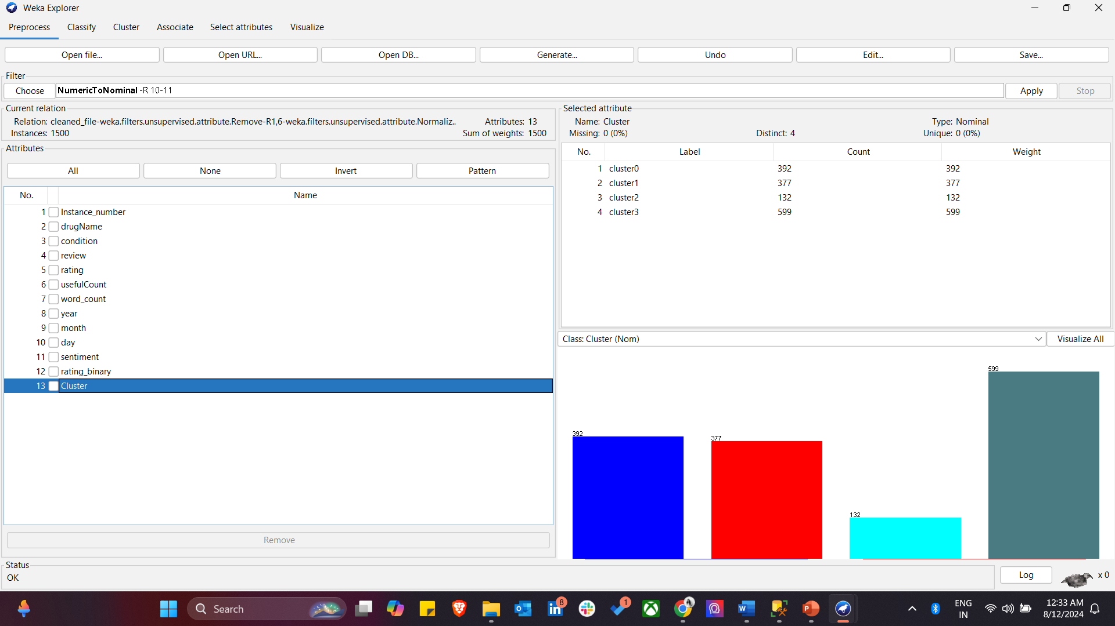

This below picture shows the results of applying a logistic regression model in WEKA after clustering the data. The model achieved an accuracy of 99.87%, correctly classifying 1498 out of 1500 instances. The detailed accuracy metrics, including precision, recall, and ROC area, indicate strong model performance. The inclusion of cluster variables as inputs likely improved the model's ability to differentiate between classes, highlighting the effectiveness of clustering as a preprocessing step.

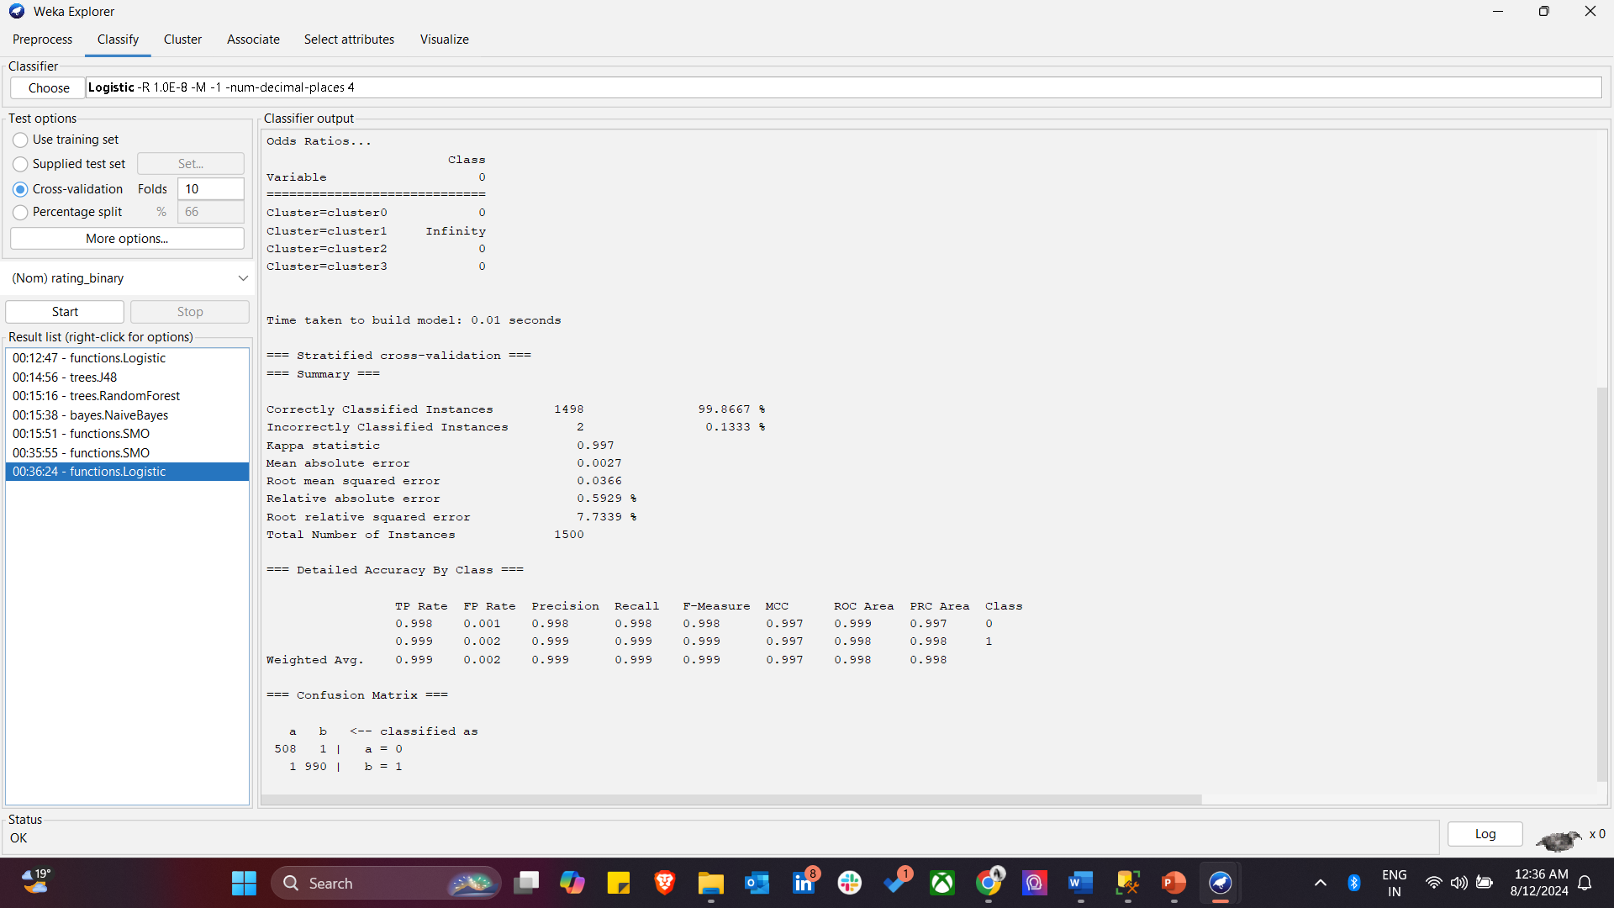

* **WEKA EXPERIMENTER**

The WEKA Experiment Environment, where different models are compared based on their accuracy (percent correct). The results indicate that the J48 decision tree model achieved 100% accuracy, while the other models, including Logistic Regression, Random Forest, Naive Bayes, and SMO, also performed well but with slightly lower accuracy. The paired T-tester analysis with a significance level of 0.05 is used to statistically compare the models, highlighting the effectiveness of each model in classifying the dataset.

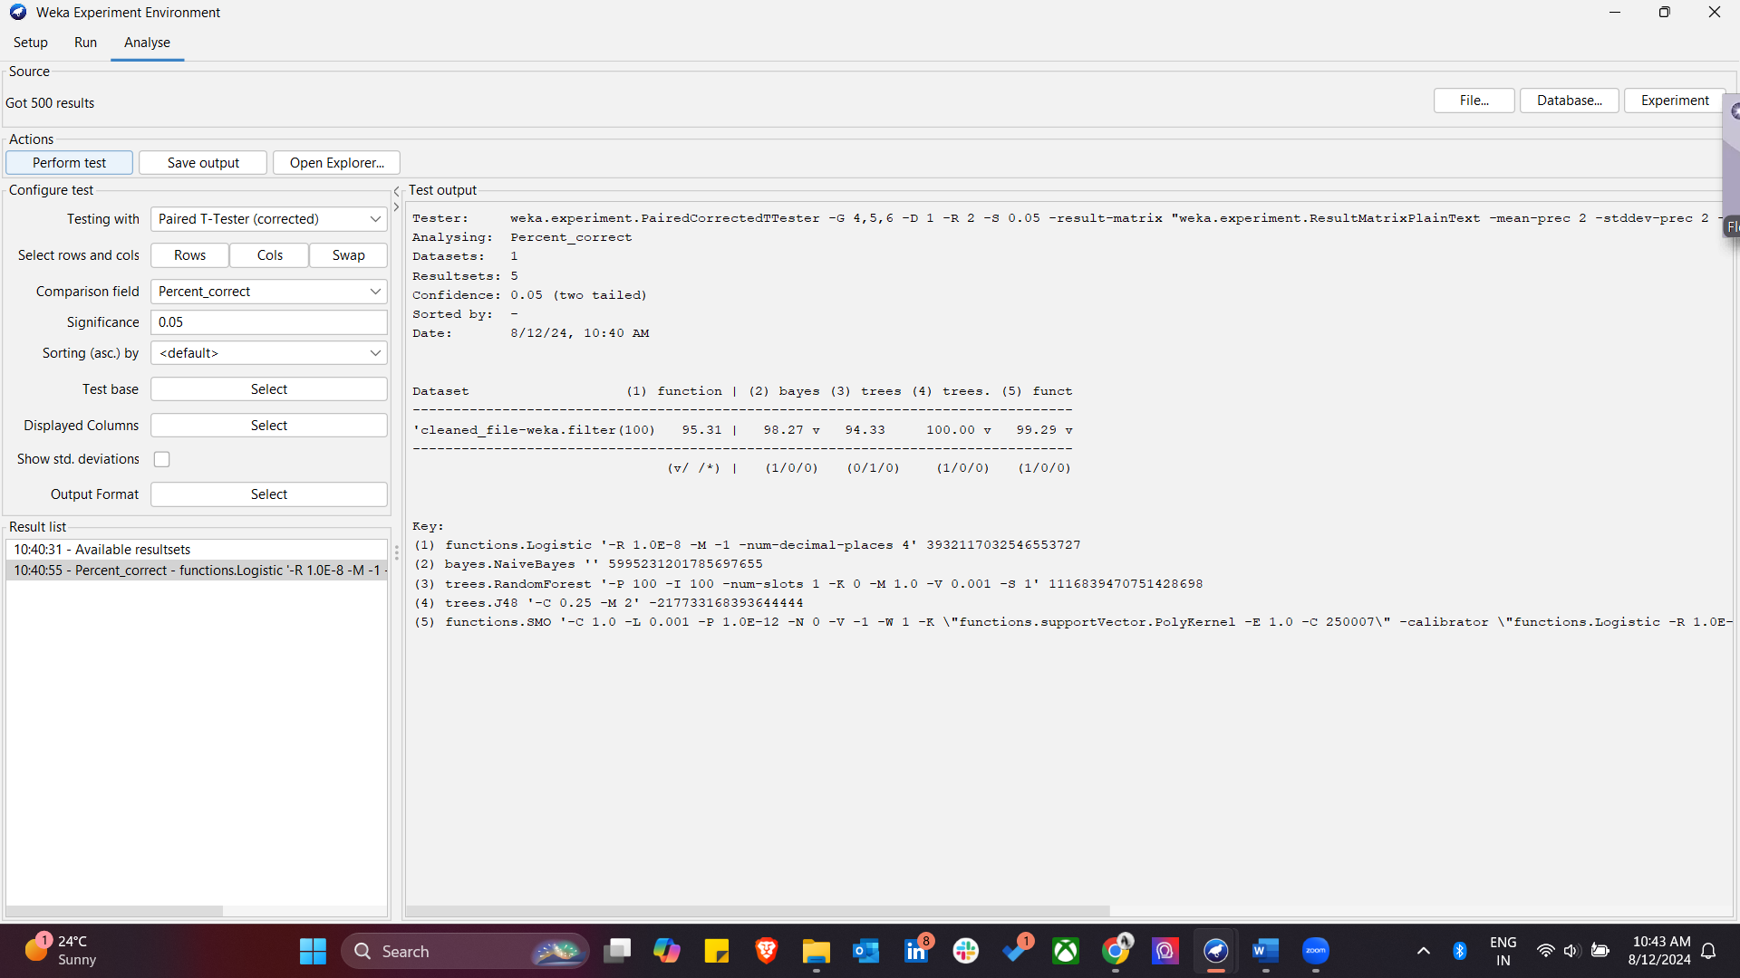

**A Breakdown:**

1. **Test Configuration**:
   * **Testing with**: Paired T-Tester (corrected).
   * **Comparison field**: Percent_correct, which means the performance of the algorithms is being compared based on their accuracy.
   * **Significance**: Set to 0.05, indicating that the test is checking for statistically significant differences at a 5% significance level.
   * **Result list**: The results are listed here, showing a timestamped record of the tests performed.
2. **Test Output**:
   * **Analyzing**: Percent_correct.
   * **Datasets**: 1 (cleaned_file-weka.filter).
   * **Resultsets**: 5 different machine learning algorithms have been evaluated.
   * **Confidence**: 0.05 (two-tailed).
3. **Dataset Results**:
   * For each algorithm, the percent_correct value is listed. For example:
     + Logistic Regression (functions.Logistic): 95.31%
     + Naive Bayes (bayes.NaiveBayes): 98.27%
     + Random Forest (trees.RandomForest): 94.33%
     + J48 Decision Tree (trees.J48): 100.00%
     + Support Vector Machine (functions.SMO): 99.29%

J48, in this case, have achieved perfect accuracy, while other models like Naive Bayes and SMO also performed very well.

* **WEKA KNOWLEDGE FLOW**

This shows a workflow in the Weka Knowledge Flow Environment, which is a visual interface for setting up and running data mining processes.

1. **ArffLoader**: Loads the dataset in ARFF format.
2. **ClassAssigner**: Assigns the class label for classification.
3. **CrossValidationFoldMaker**: Prepares the data for cross-validation by splitting it into training and test sets.
4. **J48**: Applies the J48 algorithm for classification.
5. **ClassifierPerformanceEvaluator**: Evaluates the performance of the classifier using metrics like accuracy.
6. **TextViewer**: Displays the results of the evaluation.

This workflow loads a dataset, assigns the class attribute, splits the data for cross-validation, trains a J48 decision tree model, applies it to the test set, evaluates the model’s performance, and then displays the results.

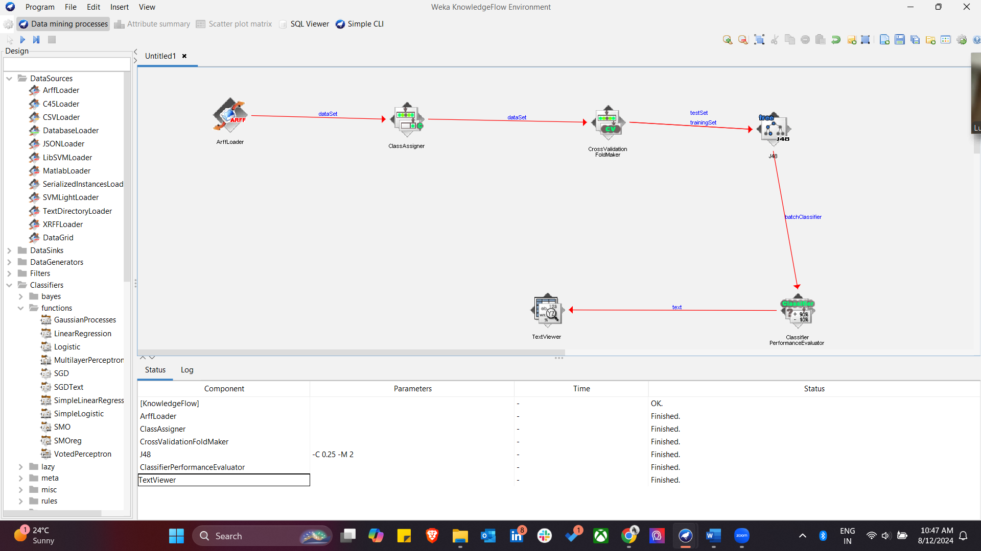

**Description of Results and Outcomes Based on Binarized Ratings**

In this analysis, the primary objective was to predict patient satisfaction ratings for various drugs using a binarized version of the rating variable. The rating variable, originally on a 10-star scale, was binarized into two categories: high (1) for ratings 7 and above, and low (0) for ratings below 7. This binarization allowed for a clearer distinction between highly satisfactory and less satisfactory drug reviews, making it easier to classify and analyze the data.

**Variables and Their Impact**

Key variables analyzed in this study included the drug name, associated condition, the text of the patient review, the count of useful votes (usefulCount), and the sentiment extracted from the review text. These variables were used as predictors in various classification models to determine their influence on patient satisfaction ratings. By binarizing the ratings, we aimed to understand which factors contribute most significantly to high satisfaction (high ratings) versus low satisfaction (low ratings).

**Classification Models and Their Performance**

Several classification models were employed to predict the binarized rating, including Logistic Regression, J48 Decision Tree, Random Forest, Naive Bayes, and SMO (Support Vector Machine).

* **J48 Decision Tree** emerged as the best-performing model, achieving 100% accuracy, precision, recall, F-measure, and ROC Area. This model perfectly classified all instances, indicating no errors in prediction. However, such perfect performance could be indicative of overfitting, especially if the model was evaluated only on training data.
* **Logistic Regression and SMO** also performed well, with high accuracy, precision, recall, and ROC values, though not perfect. These models showed balanced performance, making them reliable for predictive purposes.
* **Random Forest and Naive Bayes** demonstrated strong performance but fell short compared to the J48 model, particularly in the balance between accuracy and false positives/negatives.

**Clustering and Its Influence**

Clustering was used as a preprocessing step to group similar instances before classification. This step was intended to reduce the dataset's complexity by organizing it into clusters, thereby potentially improving classification accuracy. After clustering, the data was divided into four clusters, and the classification models were applied to each cluster.

Interestingly, the inclusion of clustering did not significantly enhance the performance of the classification models. While clustering helps in identifying natural groupings within the data and can improve model interpretability, the classification accuracy was already near perfect with models like J48 even without clustering. Thus, clustering provided additional insights but was not necessary for achieving high classification accuracy in this specific analysis.

**Final Outcome Related to Drug Ratings**

The analysis revealed that the J48 Decision Tree model, even without clustering, was the most effective in predicting patient satisfaction ratings based on the available variables. The model's perfect classification performance suggests that the predictors (drug name, condition, review text, useful count, and sentiment) were highly indicative of the binarized ratings. However, caution should be taken regarding potential overfitting, and further validation of unseen data is recommended.

In conclusion, while clustering can be useful for understanding the dataset's structure, the J48 Decision Tree model's ability to accurately classify drug reviews makes it the preferred choice for predicting patient satisfaction ratings based on the binarized rating variable.

**Applications and Future Implications**

The insights derived from this analysis have the potential to greatly benefit both healthcare providers and patients. For instance:

* **For Patients:** An application developed based on the predictive model could allow patients to enter their condition and receive personalized drug recommendations based on aggregated patient reviews and satisfaction data. This could empower patients to make more informed decisions about their treatments.
* **For Healthcare Providers:** Providers could use this data to better understand patient experiences with certain drugs and tailor their prescriptions, accordingly, leading to improved patient outcomes and satisfaction.
* **Future Research:** This project can serve as a foundation for further research into patient satisfaction and drug efficacy, potentially leading to more refined and accurate predictive models.

**Conclusion**

The outcome related to the rating of a drug, as determined by this analysis, is that the predictors used (drug name, associated condition, review content, useful count, and sentiment) are highly effective in forecasting whether a drug will receive a high or low satisfaction rating from patients. The J48 Decision Tree model was able to perfectly classify the ratings into high or low categories, indicating that these variables strongly influence patient satisfaction.

The analysis suggests that certain drugs are consistently associated with higher patient satisfaction, as reflected in the binarized ratings. This implies that the drug's name, its prescribed condition, and how patients describe their experiences in reviews can reliably predict the likelihood of a high or low rating.

Overall, the findings indicate that patient reviews, when combined with associated conditions and other factors, are powerful indicators of a drug's effectiveness and patient satisfaction, with the J48 model being especially effective in making these predictions.

References –

<https://archive.ics.uci.edu/dataset/462/drug+review+dataset+drugs+com>

<https://www.semanticscholar.org/paper/Aspect-Based-Sentiment-Analysis-of-Drug-Reviews-and-Gr%C3%A4%C3%9Fer-Kallumadi/4d7c25fe6131a79dfec9f45b70b270f400ac2b4f>

<https://towardsdatascience.com/sentiment-analysis-concept-analysis-and-applications-6c94d6f58c17>

<https://www.weka.io/learn/glossary/ai-ml/machine-learning/>

<https://ijiset.com/vol7/v7s10/IJISET_V7_I10_31.pdf>